|  |  |  |  |
| --- | --- | --- | --- |
|  | PROJECT RCPL | | |
| **REG . NO.:** | **30645-W6M1R7** | **MADE BY :** | **AVEEK DEY** |

**AIM:** WORKING WITH MAIL SERVER ON CLOUD

**PREREQUISITE KNOWLEDGE :**

**MAIL SERVER:**

A mail server (sometimes also referred to an e-mail server) is a server that handles and delivers e-mail over a network, usually over the Internet. A mail server can receive e-mails from client computers and deliver them to other mail servers. A mail server can also deliver e-mails to client computers. A client computer is normally the computer where you read your e-mails, for example your computer at home or in your office. Also an advanced mobile phone or Smartphone, with e-mail capabilities, can be regarded as a client computer in these circumstances.  
  
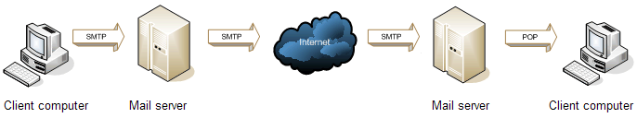

**SMTP:**

The Simple Mail Transfer Protocol is a communication protocol for electronic mail transmission. As an Internet standard, SMTP was first defined in 1982 by RFC 821, and updated in 2008 by RFC 5321 to Extended SMTP additions, which is the protocol variety in widespread use today.

**POP 3:**

The Simple Mail Transfer Protocol is a communication protocol for electronic mail transmission. As an Internet standard, SMTP was first defined in 1982 by RFC 821, and updated in 2008 by RFC 5321 to Extended SMTP additions, which is the protocol variety in widespread use today.

**IMAP:**

**IMAP** (Internet Message Access Protocol) is a standard email protocol that stores email messages on a mail server, but allows the end user to view and manipulate the messages as though they were stored locally on the end user's computing device(s).

**WORKING OF A MAIL SERVER:**

* + When we send an email, our computer connects to our email service’s mail server. A *server* is a centralized computer which manages a specific type of service. An email server for instance, handles emails. The email server responsible for sending emails is called the **SMTP**(Simple Mail Transfer Protocol) server. One SMTP server can pass on the mail to another SMTP server and relay it to the destination through several hops.
  + Every email has the sender’s address (e.g. *sender@sendermail.com*) and the recipient’s in the *To* field (e.g. *recipient@recipientmail.com*). When an email is sent, the email client connects to the SMTP server of the sender’s email service (e.g. *mailserver.sendermail.com*). The client transmits the address of the sender, the address of the recipient and the content of the message.

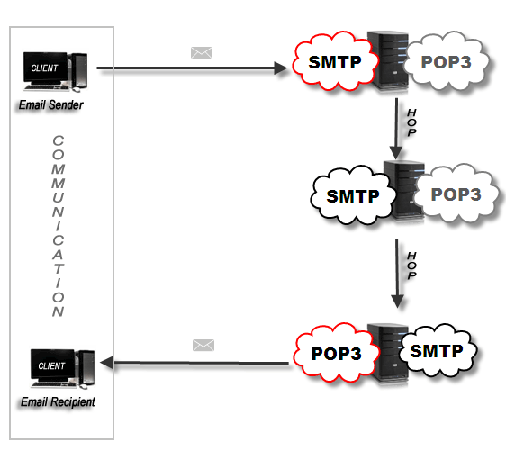

* The SMTP server goes to work at locating the whereabouts of the recipient. Using the recipient’s mail ID (i.e. recipient@recipientmail.com) it locates the domain name – e.g.*recipientmail.com*.
* Note:  If the recipient’s mail ID had the same domain name as the sender, then the process would be simpler. The SMTP server would have transferred the mail to its local outgoing mail server (POP3 or IMAP).
* Each domain name represents a unique Web address, called an **Internet protocol (IP)**address. Think of it as postal addresses of the internet. The link between domain names to their IP addresses is stored in the **Domain Name Registry**. The SMTP server then contacts the server where the registry is kept (**The DNS Server**). The DNS server sends back the address to the SMTP server.
* The SMTP server then proceeds to hand over the email to the SMTP server of the recipient’s email service (let’s call it mailserver.recipientmail.com). This SMTP server checks and confirms that the mail addressed to recipient@recipientmail.com belongs to it and hands it over to its counterpart – the *POP3 server* (or the *IMAP server*).
* **Post Office Protocol (POP3)** servers are the servers that do the job of receiving mails. The number *“˜3′* is the version number of the protocol in use. POP3 servers have mail accounts (our email IDs). Each mail account is mapped to a username-password combination. Once the message is handed over to the POP3 server, it is kept and stored in the mail account till the recipient logs in and checks the mail.
* An email client connects to the POP3 server and tells it to allow download of the email. Once downloaded to the local machine, POP3 mailboxes do not retain a copy of the email. Thus, you cannot check your emails from another PC as it has already been downloaded. To nail this difficulty, IMAP was introduced. **IMAP4**(Internet Message Access Protocol version 4) simply retains a copy of the emails on the server. This allows you to access your e-mail from any location with an internet connection.

**AWS AMAZON:**

Amazon Web Services is a subsidiary of Amazon that provides on-demand cloud computing platforms to individuals, companies and governments, on a metered pay-as-you-go basis.

**AMAZON WORKMAIL:**

Amazon WorkMail is a secure, managed business email and calendar service with support for existing desktop and mobile email client applications. Amazon WorkMail gives users the ability to seamlessly access their email, contacts, and calendars using the client application of their choice, including Microsoft Outlook, native iOS and Android email applications, any client application supporting the IMAP protocol, or directly through a web browser. You can integrate Amazon WorkMail with your existing corporate directory, use email journaling to meet compliance requirements, and control both the keys that encrypt your data and the location in which your data is stored. You can also set up interoperability with Microsoft Exchange Server, and programmatically manage users, groups, and resources using the Amazon WorkMail SDK.

**BENEFITS:**

**1.MANAGED SERVICE**

**2.ANYWHERE ACCESS**

**3.LOW COST**

**4.ENTERPRISE-GRADE SECURITY**

**5.OUTLOOK COMPATIBILITY**

**MIGRATION OPTION IN WORKMAIL:**

Amazon has collaborated with email migration specialists [audriga](https://workmail.audriga.com/) and [Transend](https://www.transend.com/products/transend-migrator-amazon-workmail/) to make it easier for you to move your email to Amazon WorkMail. Now you can use these solutions to migrate email, meetings, contacts, and notes from Microsoft Office 365, Microsoft Exchange Server, Google Apps for Work, IMAP and POP*.

audriga provides a cloud-based, [self-service email migration solution](https://workmail.audriga.com/) that allows you to migrate from your existing email solution to Amazon WorkMail, without installing any software. It connects via standard protocols and copies your data directly to your Amazon WorkMail accounts. audriga migrates emails, contacts, calendars, tasks, and notes.

Transend provides [Transend Migrator for Amazon WorkMail](https://www.transend.com/products/transend-migrator-amazon-workmail/) - an easy to use utility for migrating email data from your existing email solution to Amazon WorkMail. Transend Migrator allows you to migrate a single mailbox or batch thousands of accounts at once, and moves messages, address books, calendars, and tasks in a single migration process. For qualified projects, Transend offers free consulting services in addition to a robust support and maintenance package.

## IMAP Protocol Support:

Amazon WorkMail allows you to access your email with any email client application that supports the IMAP protocol. This allows you to choose from a broad range of clients on the platform of your choice, including those that do not offer support for Microsoft Exchange compatible protocols like Microsoft Exchange Web Services and Microsoft ActiveSync. It also allows you to integrate Amazon WorkMail with IT applications and systems which rely on the IMAP protocol to access email. Amazon WorkMail offers an SMTP gateway so that you can send email through WorkMail without the need to configure a different SMTP endpoint.

## Feature-Rich Web Client:

Amazon WorkMail provides a feature-rich web client so that users can access their email and calendars, view shared calendars, quickly schedule meetings with co-workers, or search the company address book using their browser. Users can also manage their out-of-office replies and book resources, such as conference rooms. The Amazon WorkMail web client is also integrated with Amazon WorkDocs to provide users with the ability to attach files stored in WorkDocs to an email, replace an existing email attachment with a WorkDocs link, and securely save attachments to WorkDocs with a single click. The Amazon WorkMail web client supports most popular browsers, including Firefox, Chrome, Safari, and Edge.

**AMAZON WORKMAIL SYSTEM REQUIREMENT:**

Amazon WorkMail works with all major mobile devices and operating systems that support the Exchange ActiveSync protocol. These include the iPad, iPhone, Amazon Fire, Android, Windows Phone, and BlackBerry 10. Users of macOS can add their Amazon WorkMail account to their Mail, Calendar, and Contacts apps.

You can access Amazon WorkMail from Microsoft Outlook. You must have a valid Microsoft Outlook license to use it with Amazon WorkMail, which offers native support for the following versions:

* Outlook 2007, Outlook 2010, Outlook 2013, Outlook 2016, and Outlook 2019
* Outlook 2010 and Outlook 2013 Click-to-Run
* Outlook for Mac 2011, Outlook 2016 for Mac, and Outlook 2019 for Mac

Amazon WorkMail supports IMAP clients. For the required configuration, see [Connect to your IMAP Client Application](https://docs.aws.amazon.com/workmail/latest/userguide/using_IMAP_client.html). POP3 clients are not currently supported.

You can access Amazon WorkMail using the web application: https://*alias*.awsapps.com/mail.

**AMAZON WORKMAIL CONCEPTS:**

Amazon WorkMail works with all major mobile devices and operating systems that support the Exchange ActiveSync protocol. These include the iPad, iPhone, Amazon Fire, Android, Windows Phone, and BlackBerry 10. Users of macOS can add their Amazon WorkMail account to their Mail, Calendar, and Contacts apps.

You can access Amazon WorkMail from Microsoft Outlook. You must have a valid Microsoft Outlook license to use it with Amazon WorkMail, which offers native support for the following versions:

* Outlook 2007, Outlook 2010, Outlook 2013, Outlook 2016, and Outlook 2019
* Outlook 2010 and Outlook 2013 Click-to-Run
* Outlook for Mac 2011, Outlook 2016 for Mac, and Outlook 2019 for Mac

Amazon WorkMail supports IMAP clients. For the required configuration, see [Connect to your IMAP Client Application](https://docs.aws.amazon.com/workmail/latest/userguide/using_IMAP_client.html). POP3 clients are not currently supported.

**AMAZON WORKMAIL RESOURCES:**

The following related resources can help you as you work with this service.

* [**Classes & Workshops**](https://aws.amazon.com/training/course-descriptions/) – Links to role-based and specialty courses as well as self-paced labs to help sharpen your AWS skills and gain practical experience.
* [**AWS Developer Tools**](https://aws.amazon.com/tools/) – Links to developer tools, SDKs, IDE toolkits, and command line tools for developing and managing AWS applications.
* [**AWS Whitepapers**](https://aws.amazon.com/whitepapers/) – Links to a comprehensive list of technical AWS whitepapers, covering topics such as architecture, security, and economics and authored by AWS Solutions Architects or other technical experts.
* [**AWS Support Center**](https://console.aws.amazon.com/support/home#/) – The hub for creating and managing your AWS Support cases. Also includes links to other helpful resources, such as forums, technical FAQs, service health status, and AWS Trusted Advisor.
* [**AWS Support**](https://aws.amazon.com/premiumsupport/) – The primary web page for information about AWS Support, a one-on-one, fast-response support channel to help you build and run applications in the cloud.
* [**Contact Us**](https://aws.amazon.com/contact-us/) – A central contact point for inquiries concerning AWS billing, account, events, abuse, and other issues.
* [**AWS Site Terms**](https://aws.amazon.com/terms/) – Detailed information about our copyright and trademark; your account, license, and site access; and other topics.

## Amazon WorkMail Pricing:

With Amazon WorkMail, there are no upfront fees or commitments. You pay only for active user accounts. For more specific information about pricing, see [Pricing](http://aws.amazon.com/workmail/pricing).

**PROCEDURE:**

**1.Open the amazon aws account with your username and password .Then go to services and type workmail.**

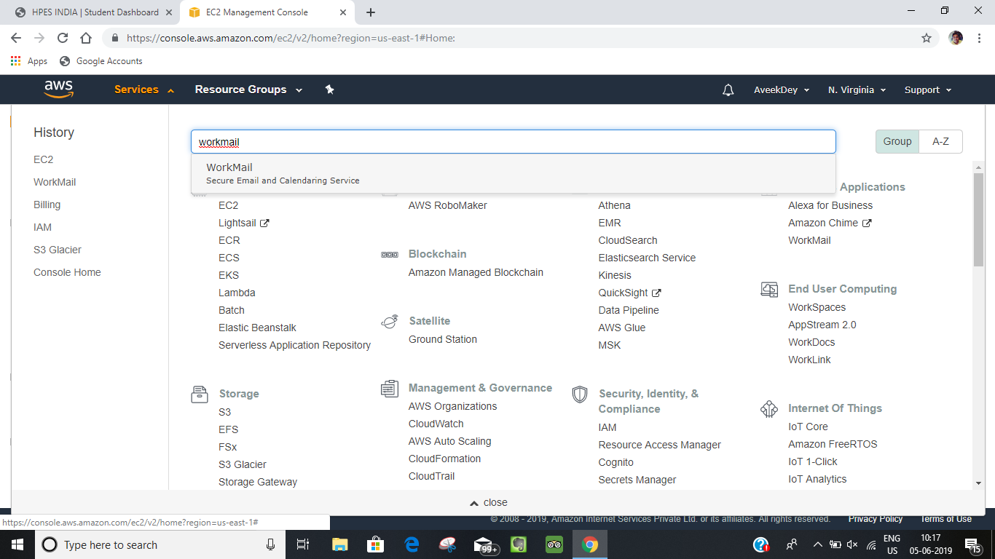

**2.**

**Then this page will display on the screen.**

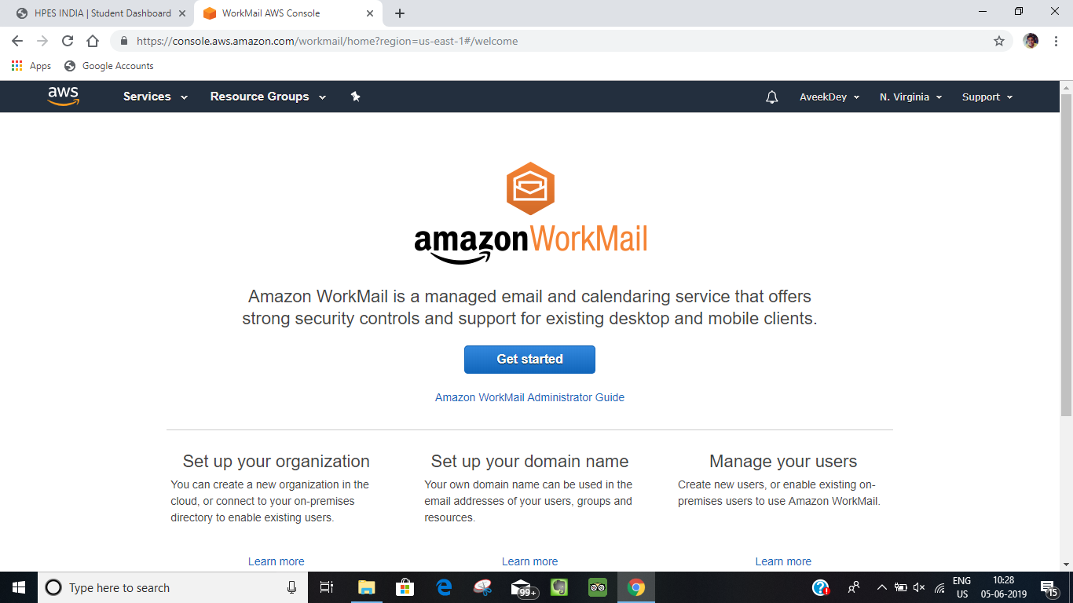

**3.**

**Then click on “GET STARTED” option then this page will display.**

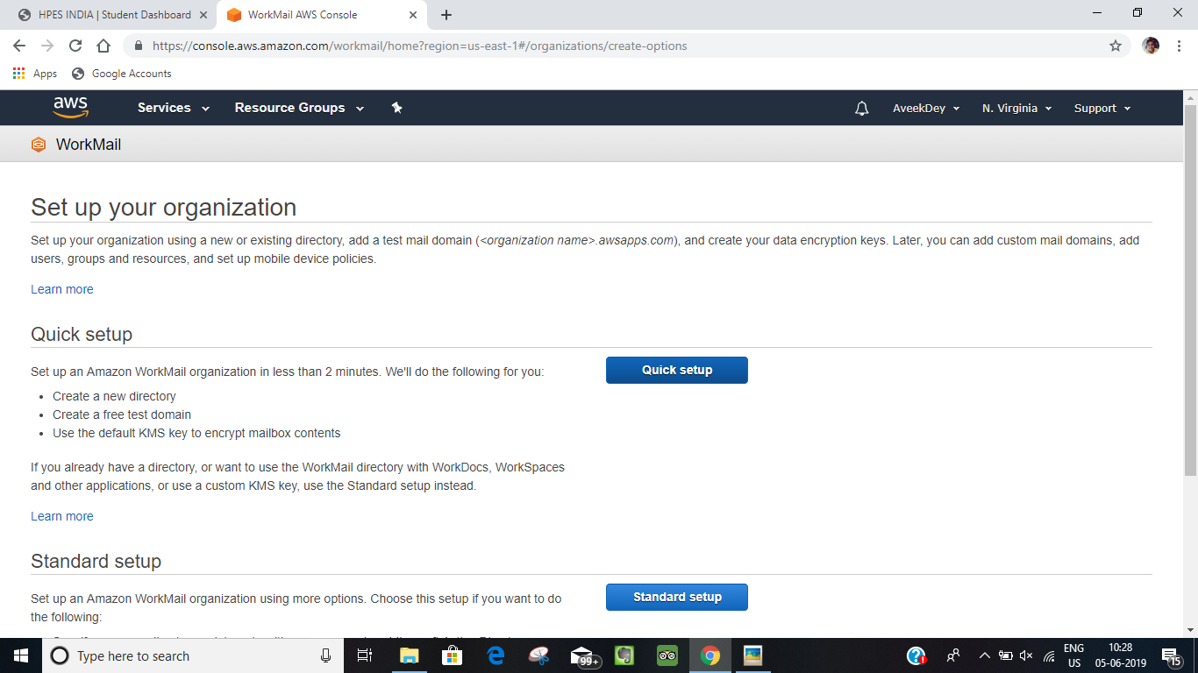

**4.Then click on “QUICK SETUP” option , then this page will display then give the “organization name” so as to create.**

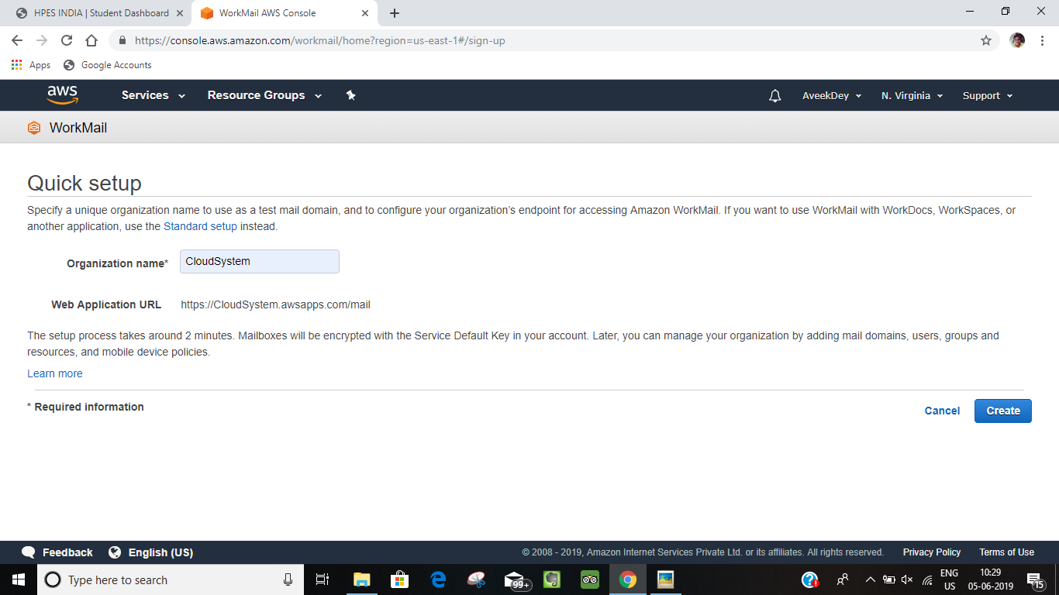

**5.Then after creating this page will display on the screen and the oraganisation that you have being created will have the status of creating , then we have wait till the organization status became active and is showing a default main domain .**

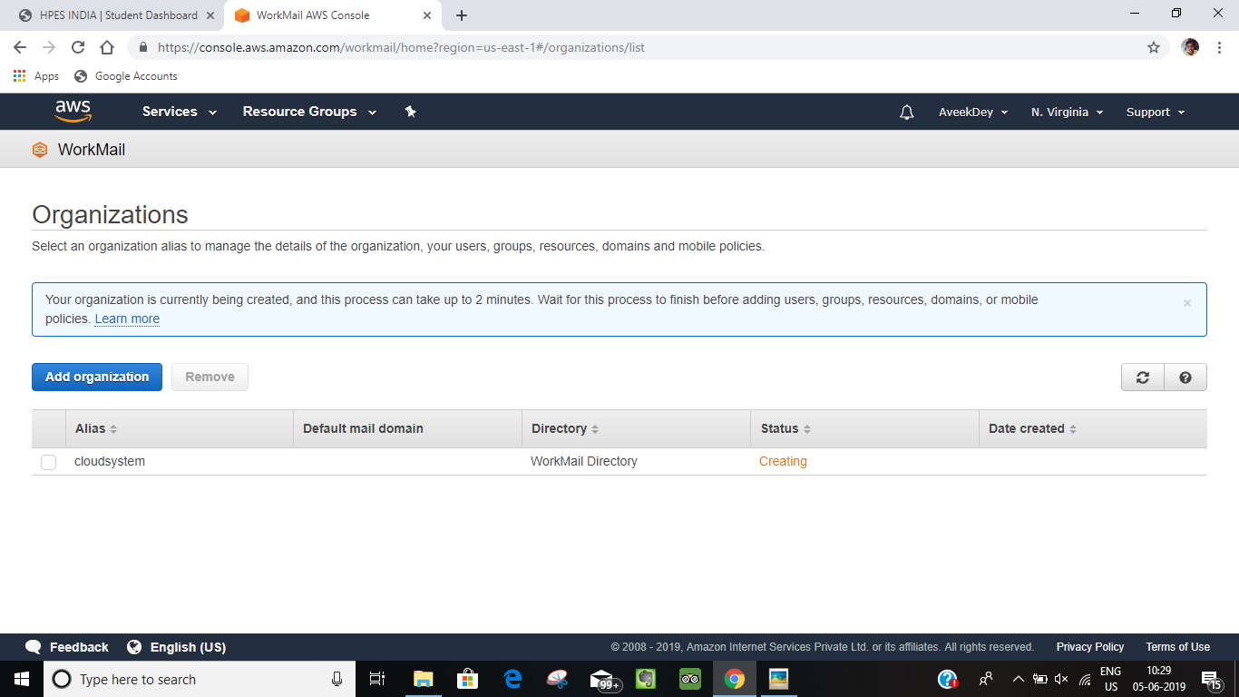

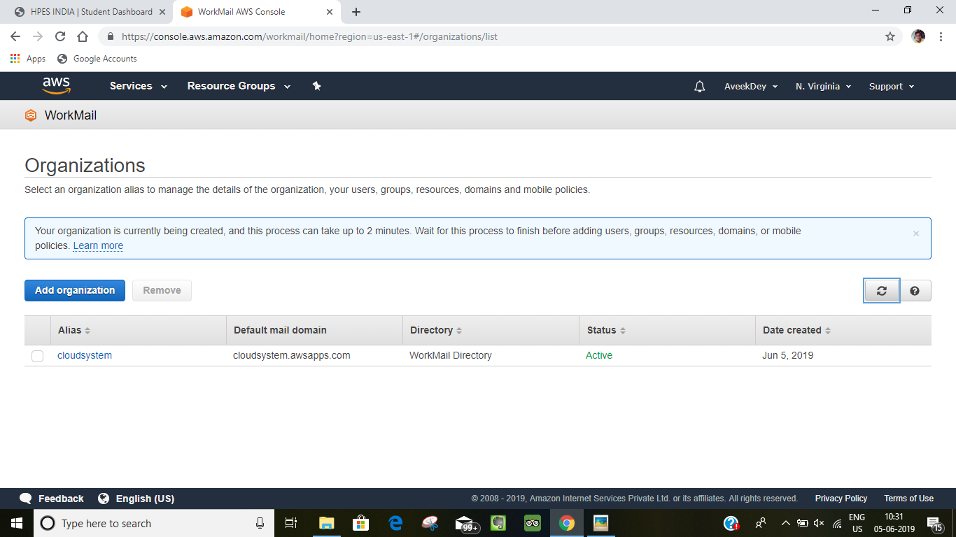

**6.Then click on the organisation name which have been created.**

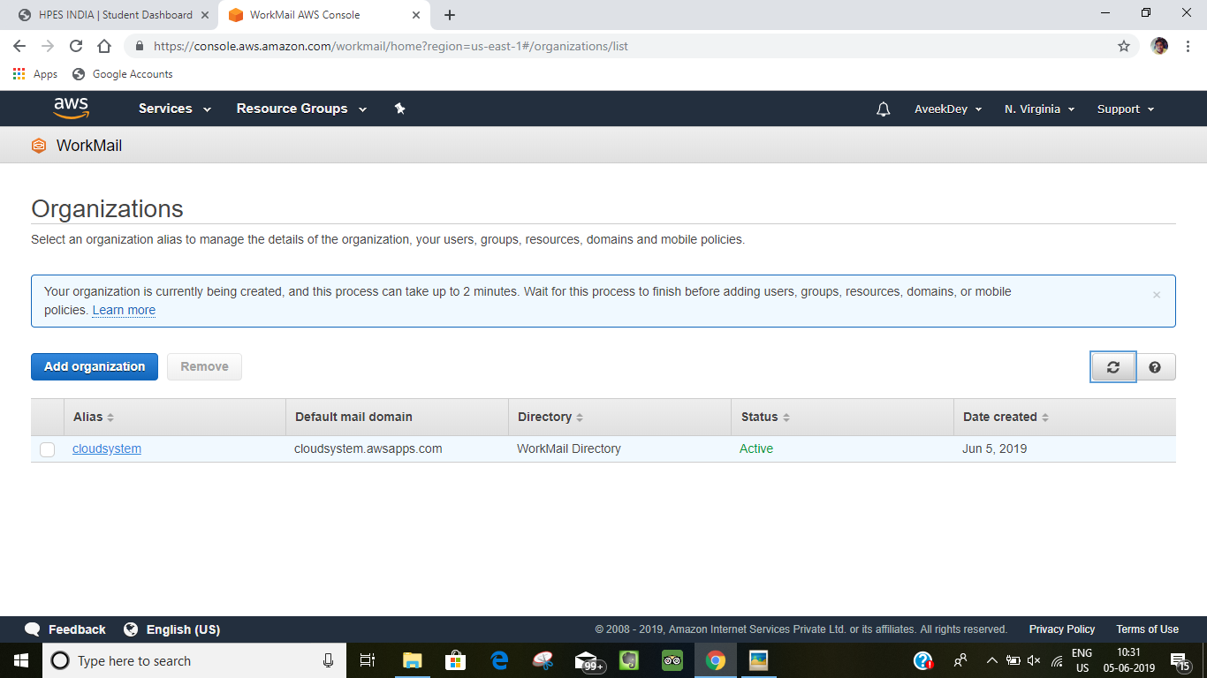

**7.Then this page will display on the screen of the user.**

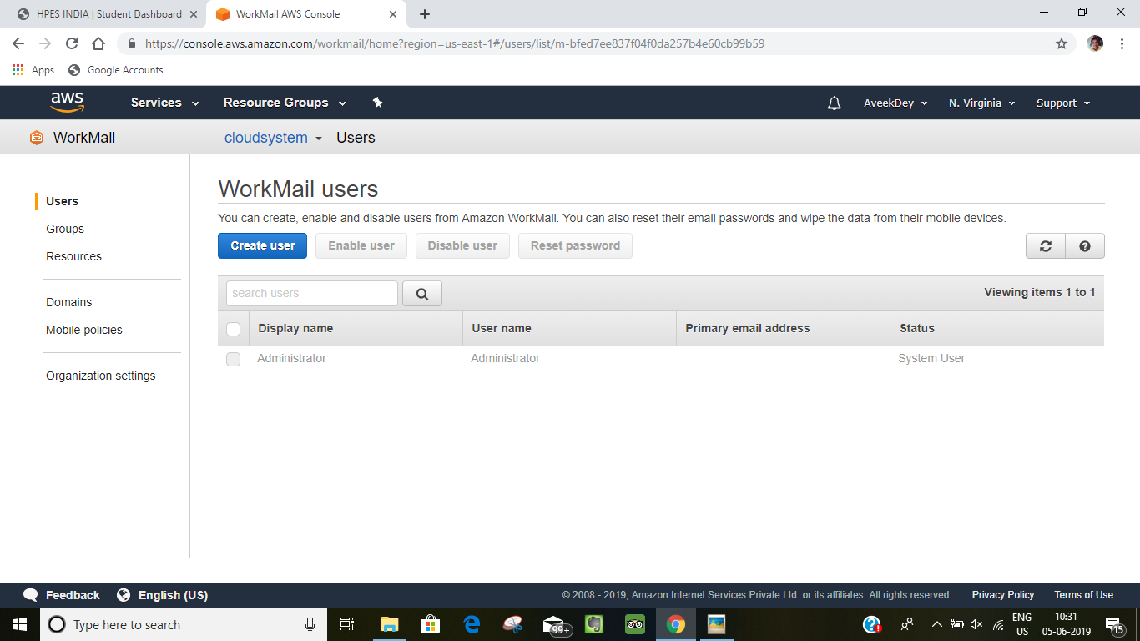

**8.Then click on “Create user” and add the user details.**

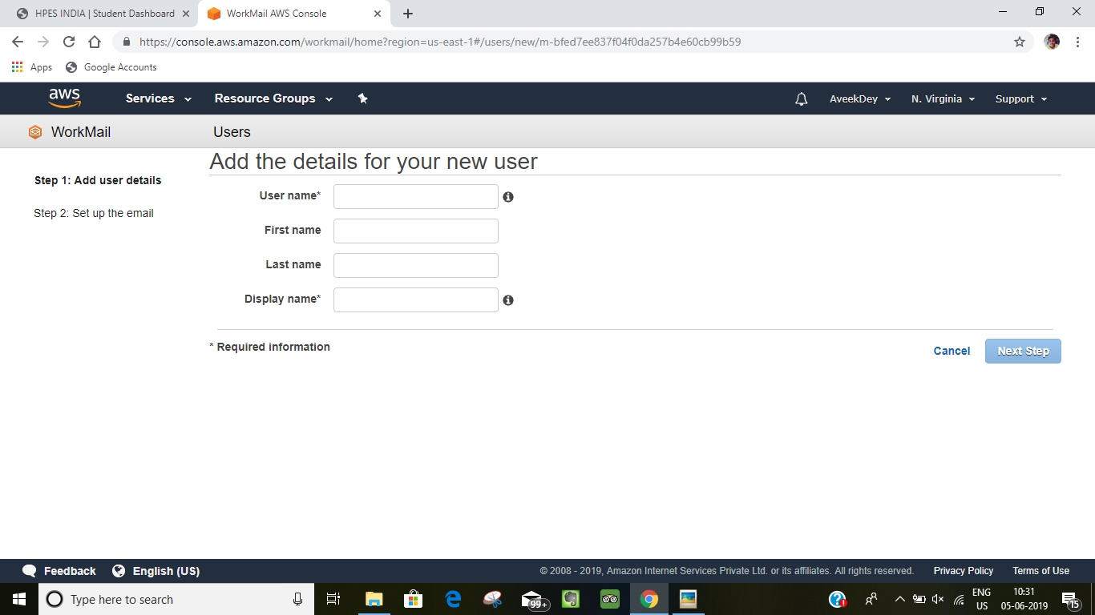

**9.Then fill up the username and display and the other details and then click on the “Next Step”**

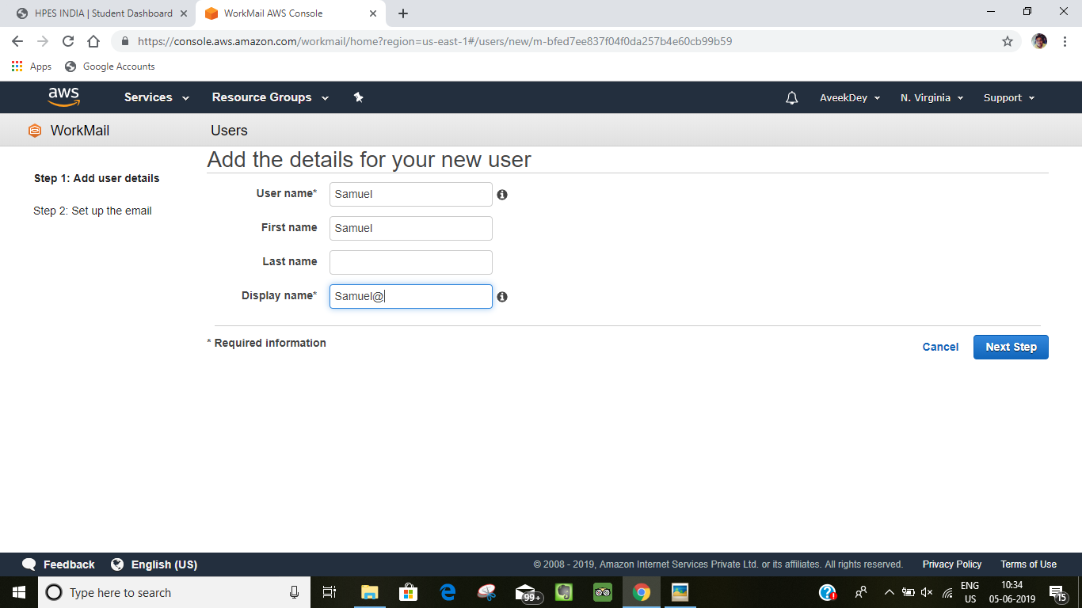

**10.Then click on the email and the password and then click on the “ add user”.**

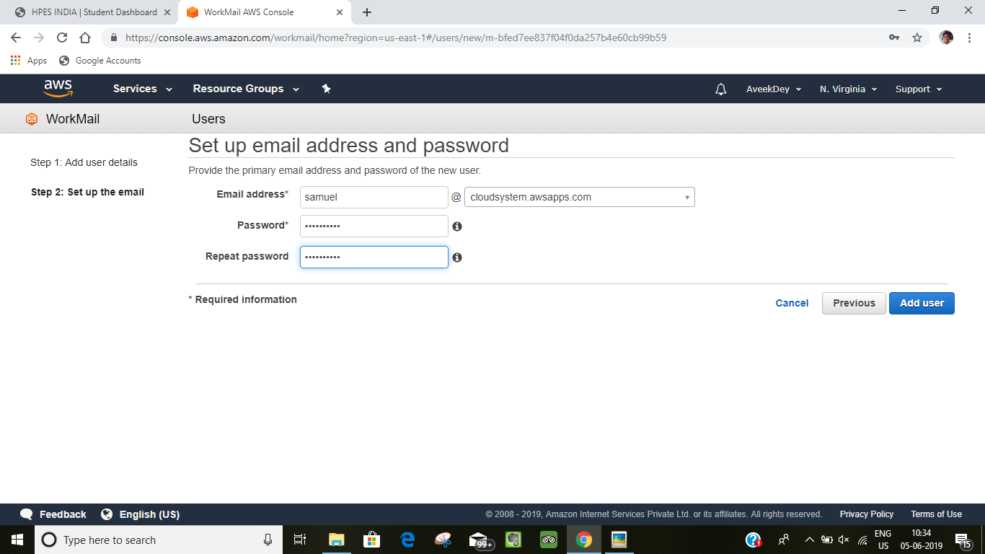

**11.Then it will show the message of user being successfully added.**

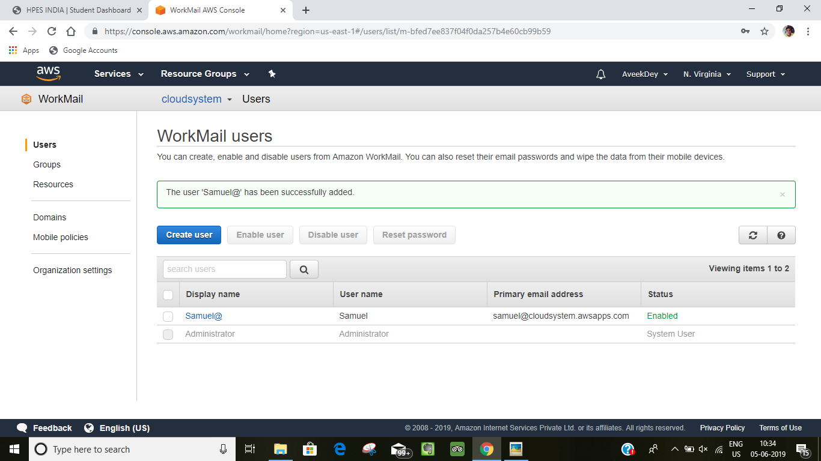

**12.Repeat step-11 to add another user.**

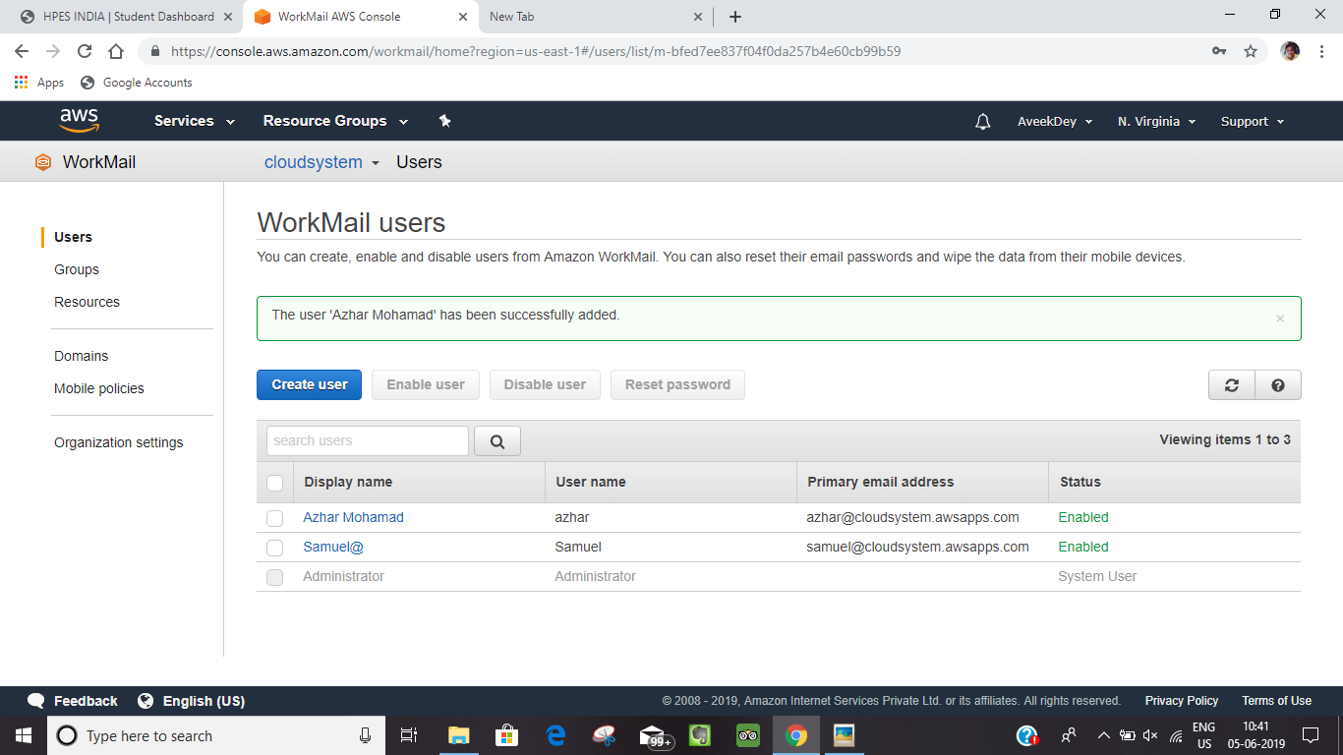

**13.Then go to “organizational settings” in the left-side menu and this page will display on the user screen.**

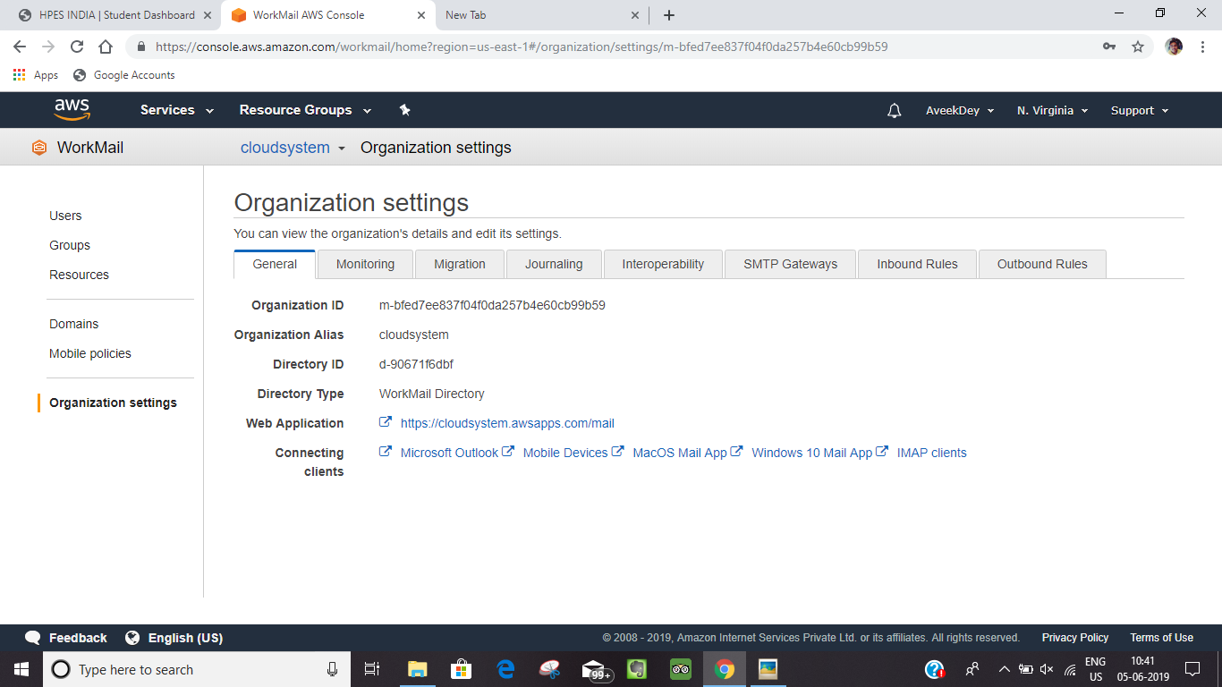

**14.Then click on the “web application” and open it in the new tab.**

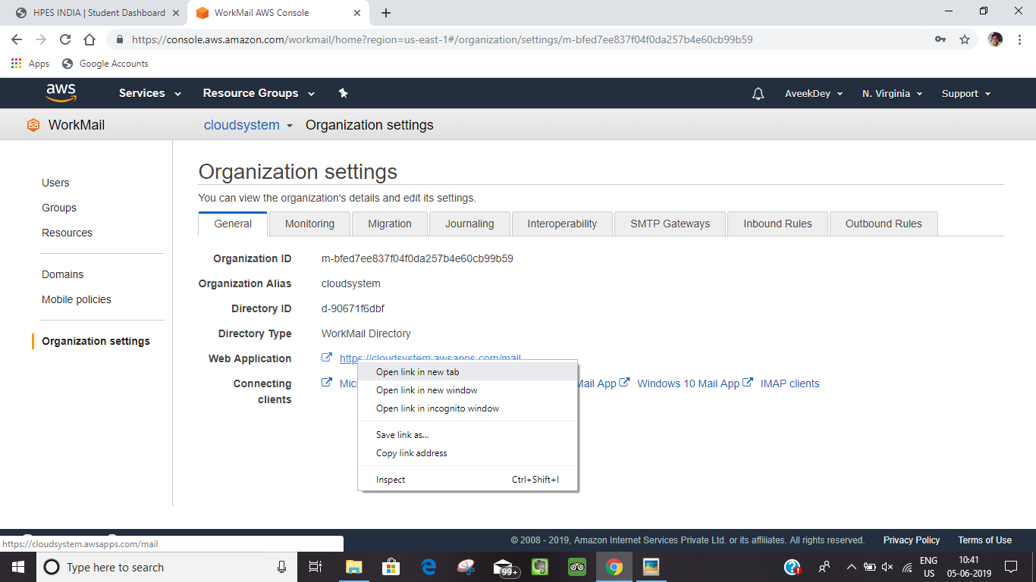

**15.Then this page will display on the screen.**

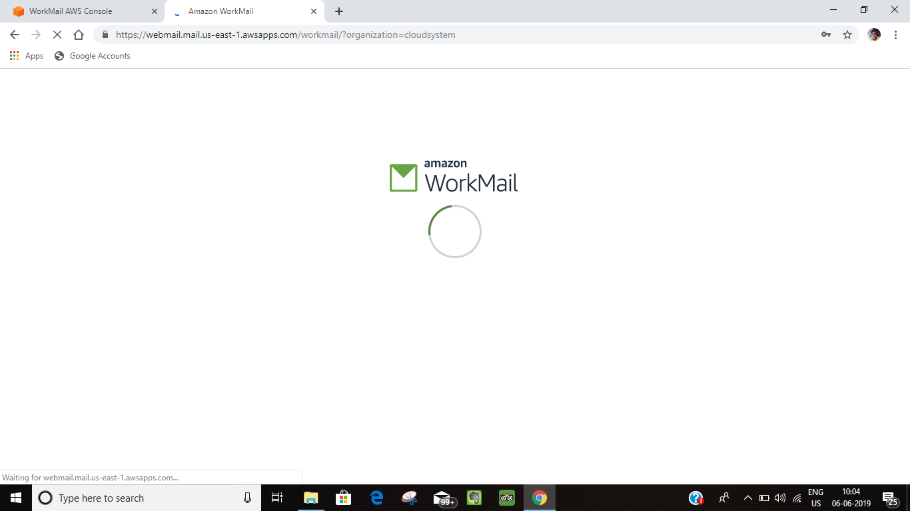

**16.Then sign-in in the “Amazon Work-Mail” with the user-name and password.**

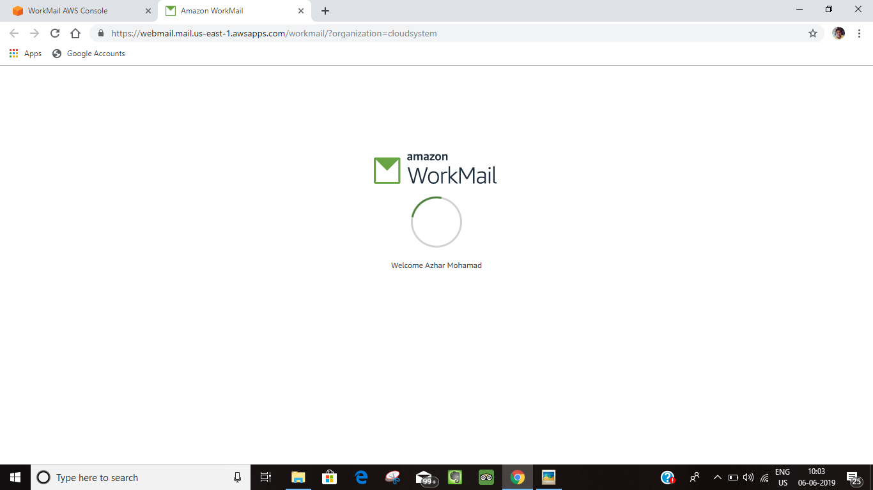

**17.Then go to “New-Item” and click on “New-email”**

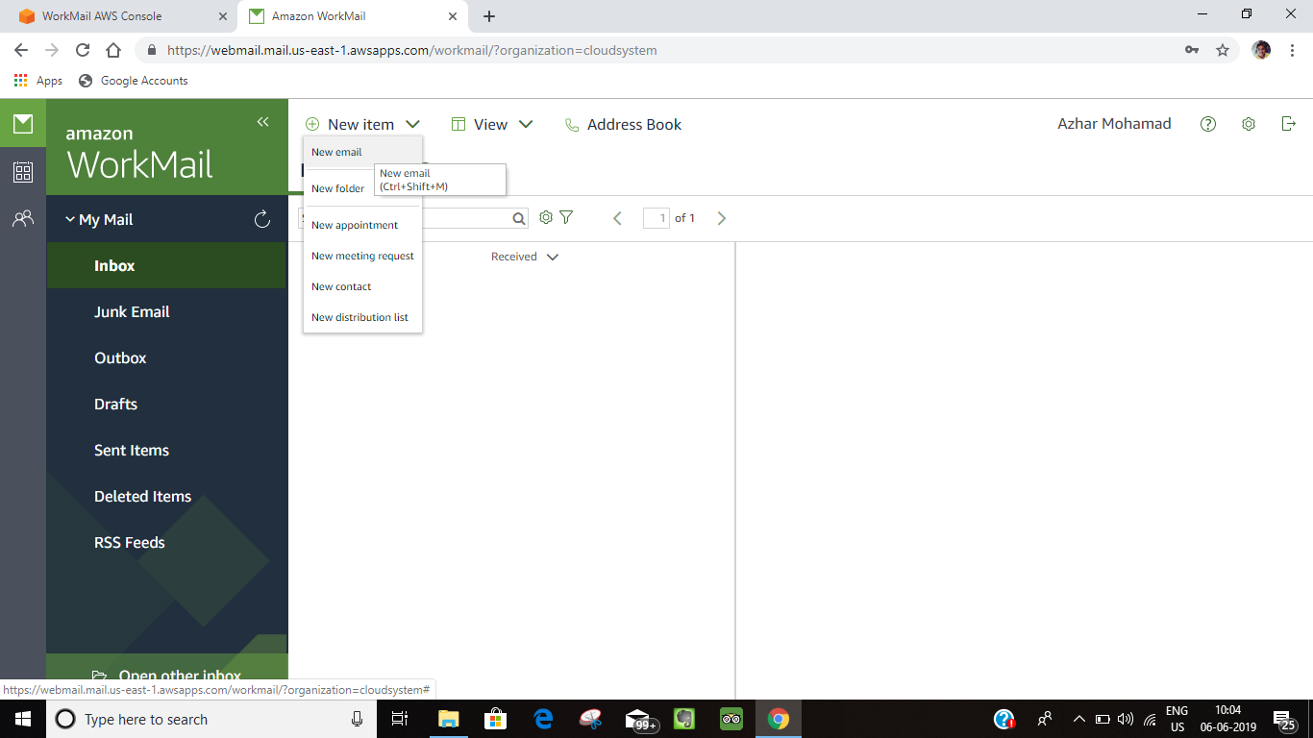

**18.Then this page will display on the screen and click on “TO” option.**

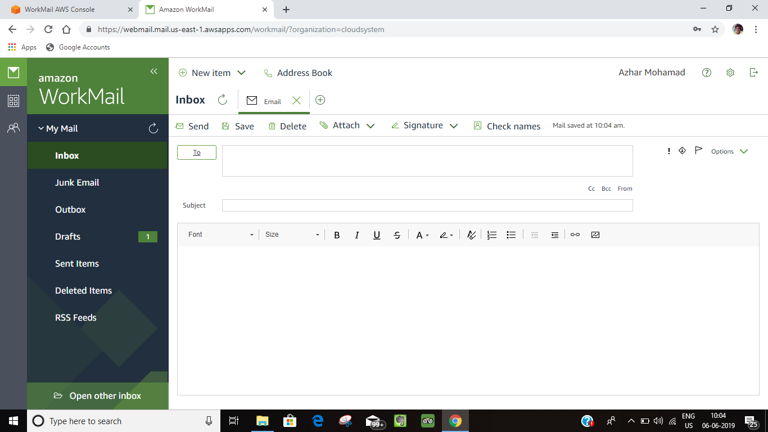

**19.Then this page will display and fill up the ”To” and “CC” option ,here in the “To” option add the two user created and in the “Cc” and then click on the “Ok” option and the user must be a already added to the “Users” list.**

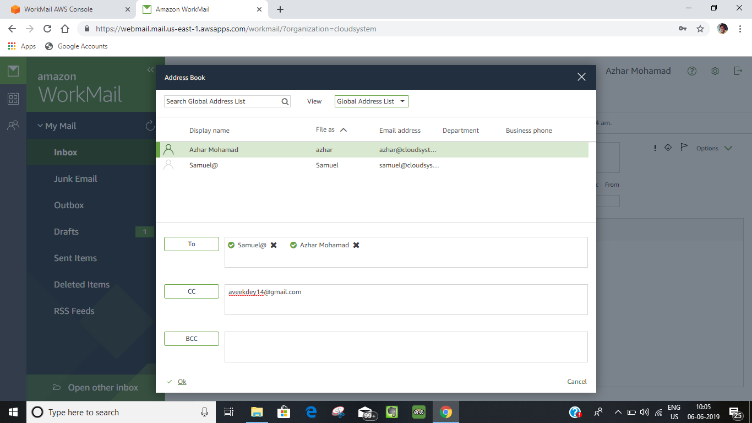

**20.Then fill the subject and message-body of the email and then click on the send option to sent the email.**

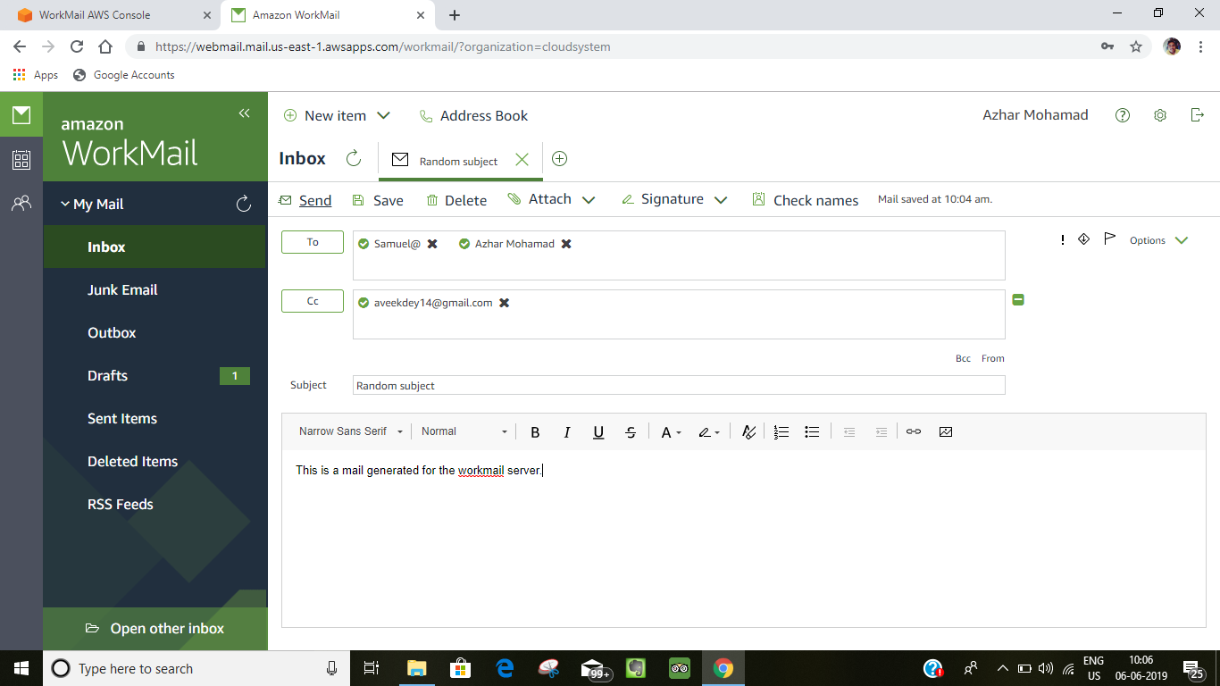

**21.Then the message will be sent and it will display as this to whom the message is sent.**

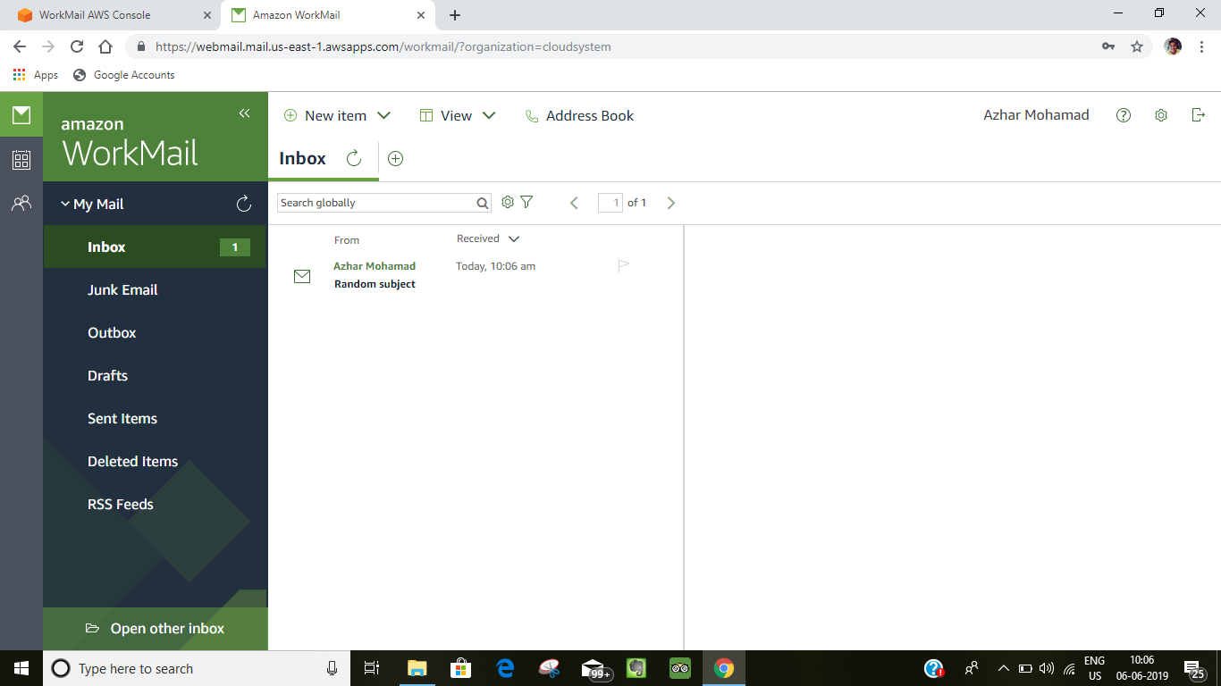

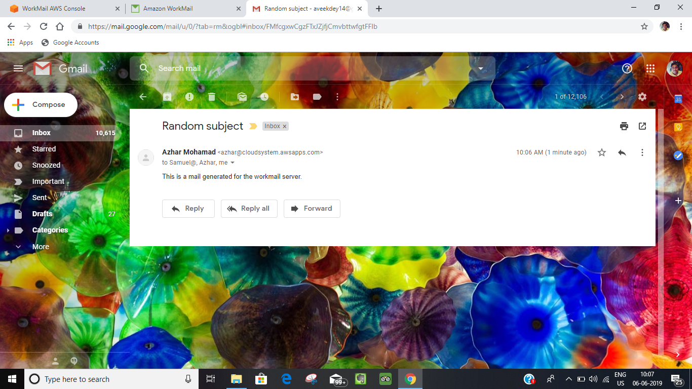

**22.Then go to “Groups” in the amazon console.**

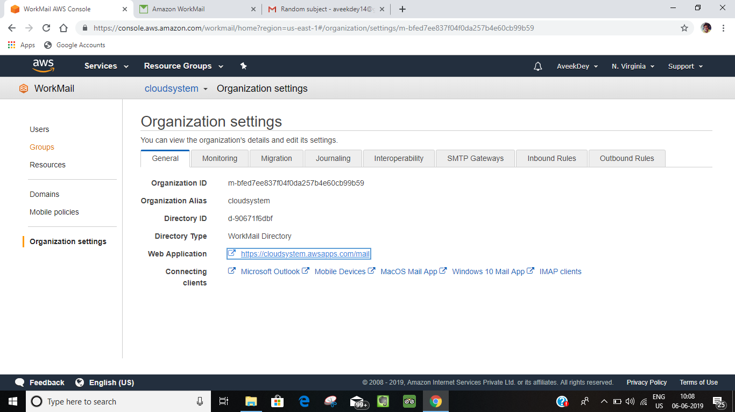

**Using WorkMail we can also send email to a particular group of people in an organization rather than adding individual user at a time we can add a whole group .**

**Procedure:**

**1.Then this page will display on the screen and then click on “Create Group”.**

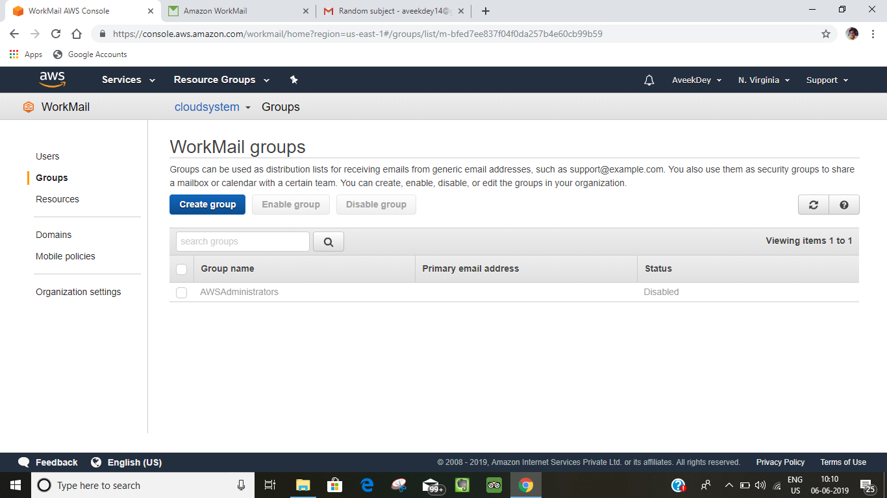

**2.Then give the “Group name” and “email-address” and then click on the “Add group members”**

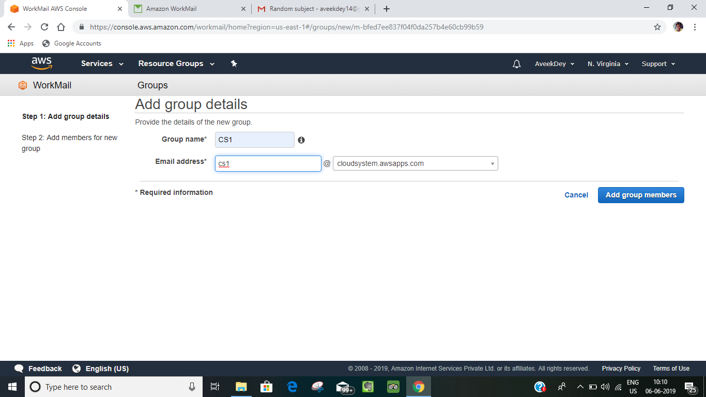

**3.Then add the members in the group .**

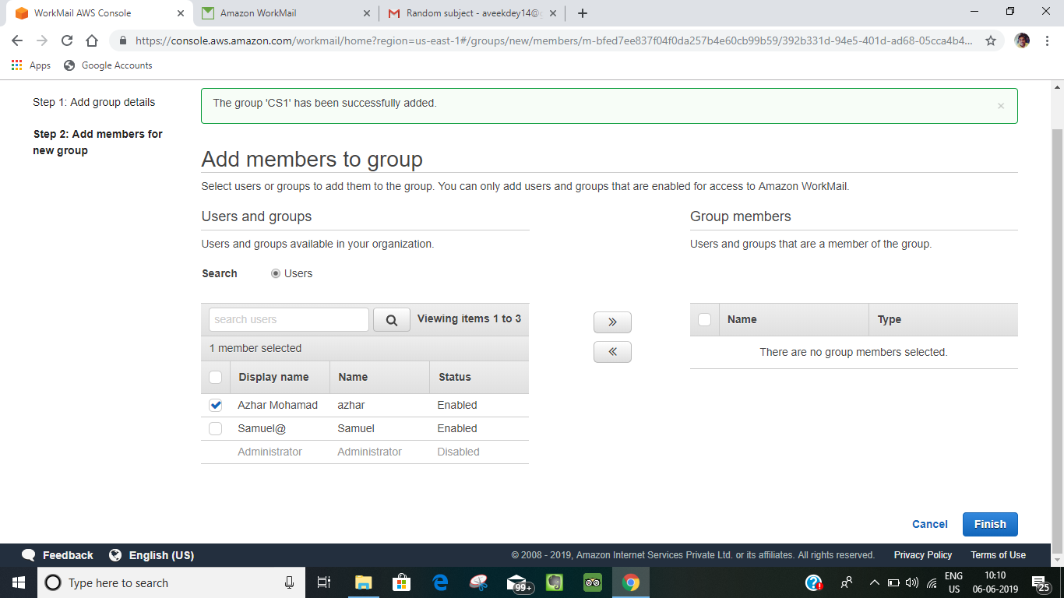

**4.For adding the members tick on the user you want to add and then click on the “>>” button to add and “<<” to remove the user.**

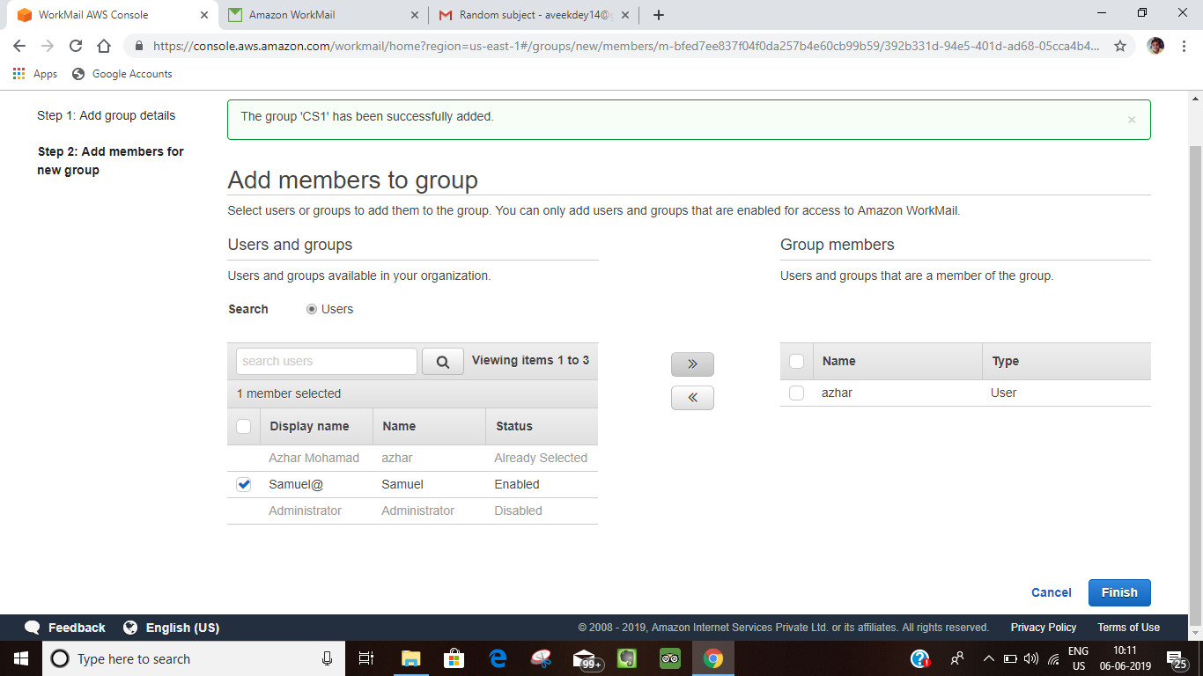

**5.Then a new group will be created on that name.**

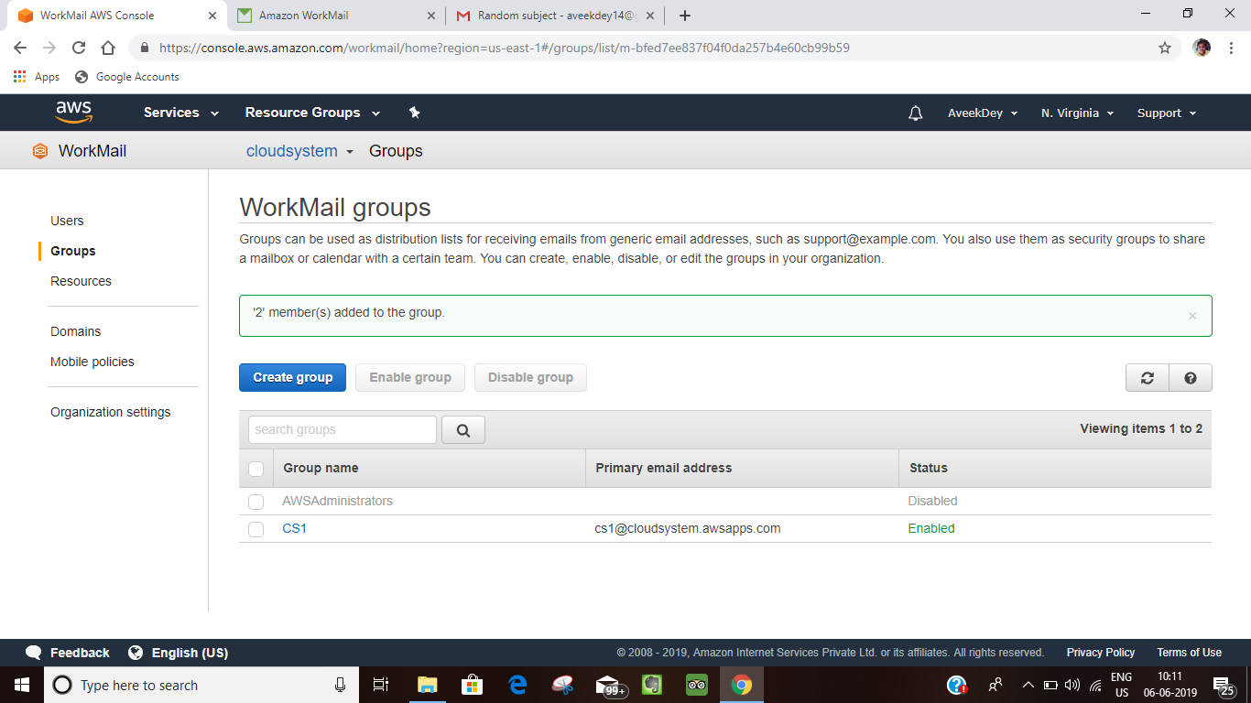

**In WorkMail we can also make “Resources” so that it can be requested and can be issued to the members of an organization.**

**Procedure:**

**1.So first of all we have to add the resource in the resource list so that someone can request for that resource.Go to “Resources” and click on “Add resources”.**

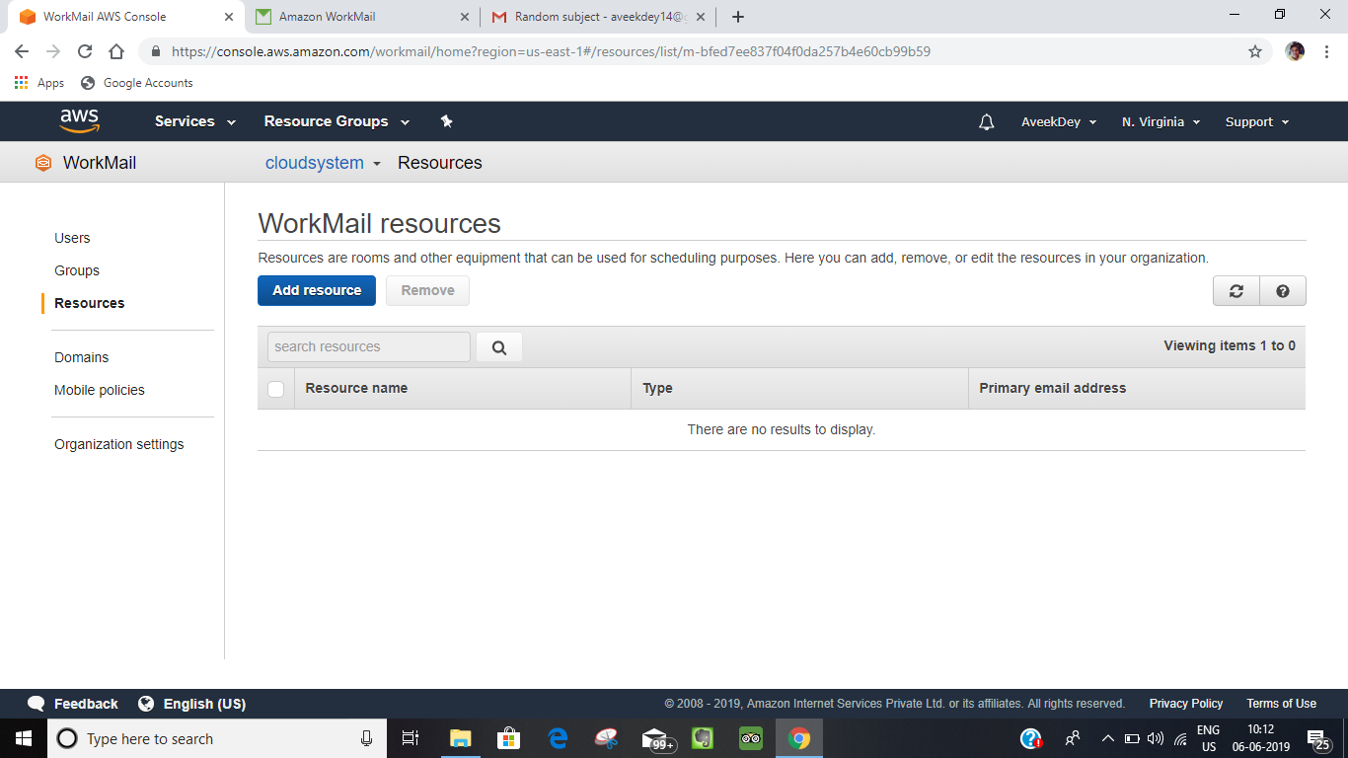

**2.Then give the resource name ,description and all the other details regarding that resource and click on create.**

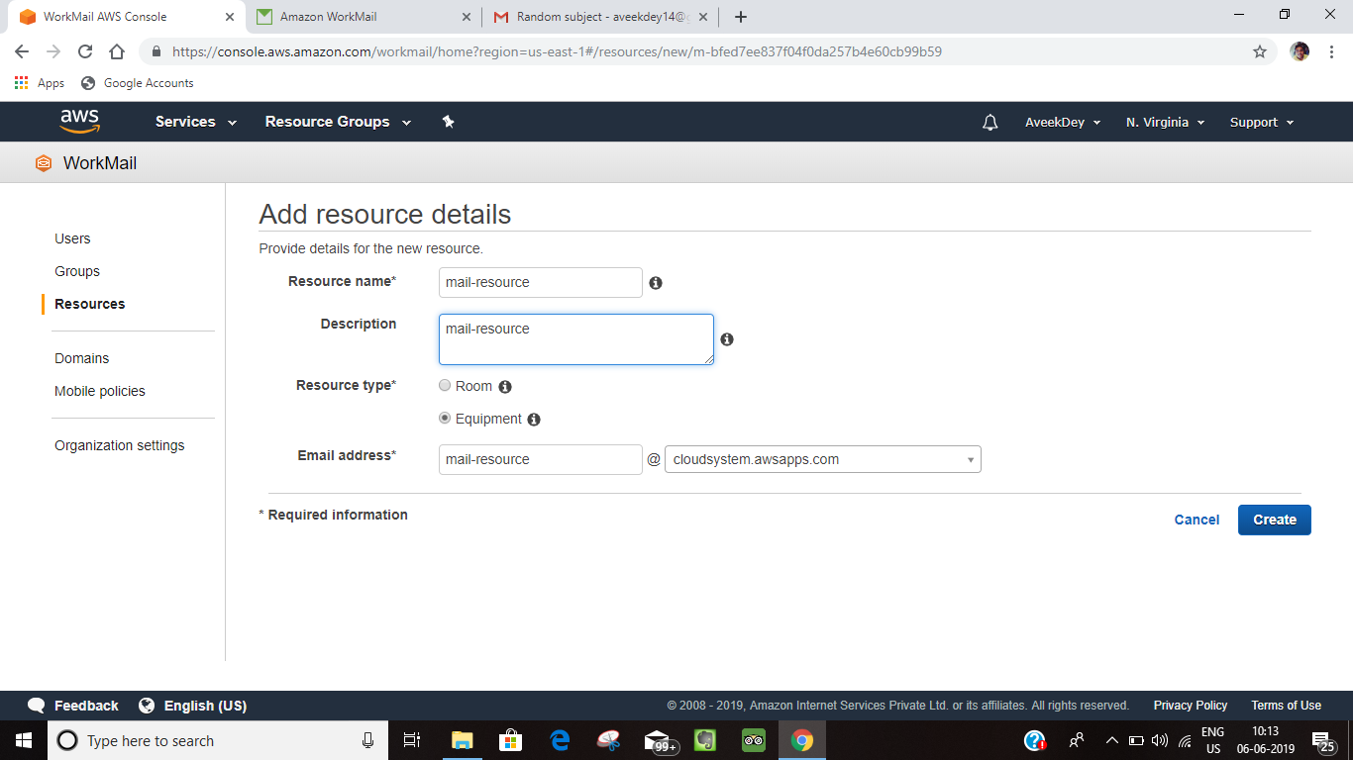

**3.Then a resource will be created.**

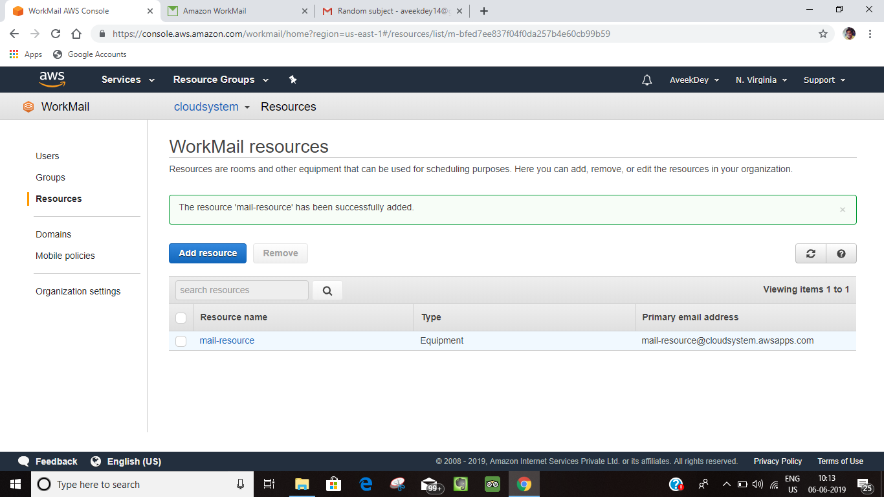

**So as to request for a resource using the email.**

**1.Open your mail and go to New-Item and click on New-appointment.**

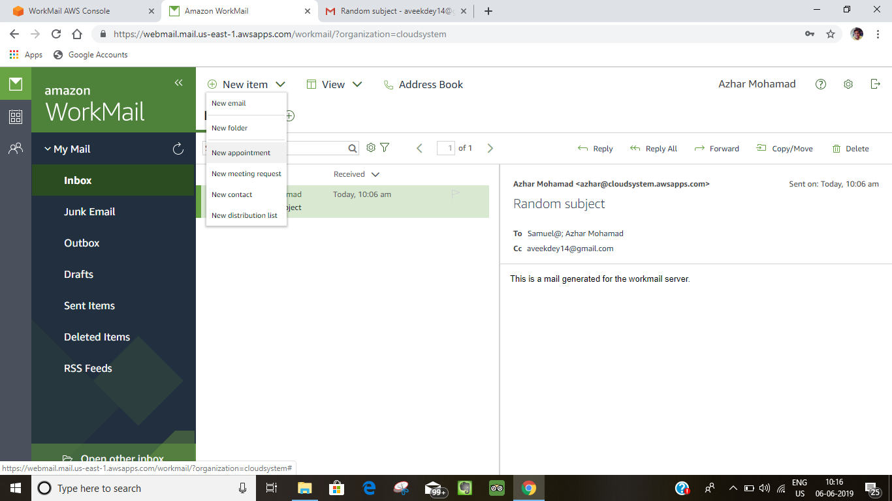

**2.Then this page will display in the screen.**

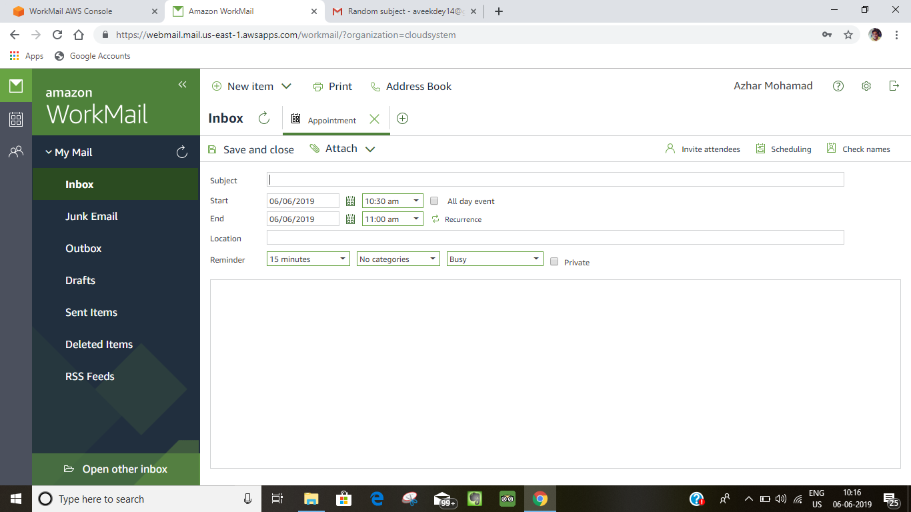

**3.Then click on Invite-Attendees.**

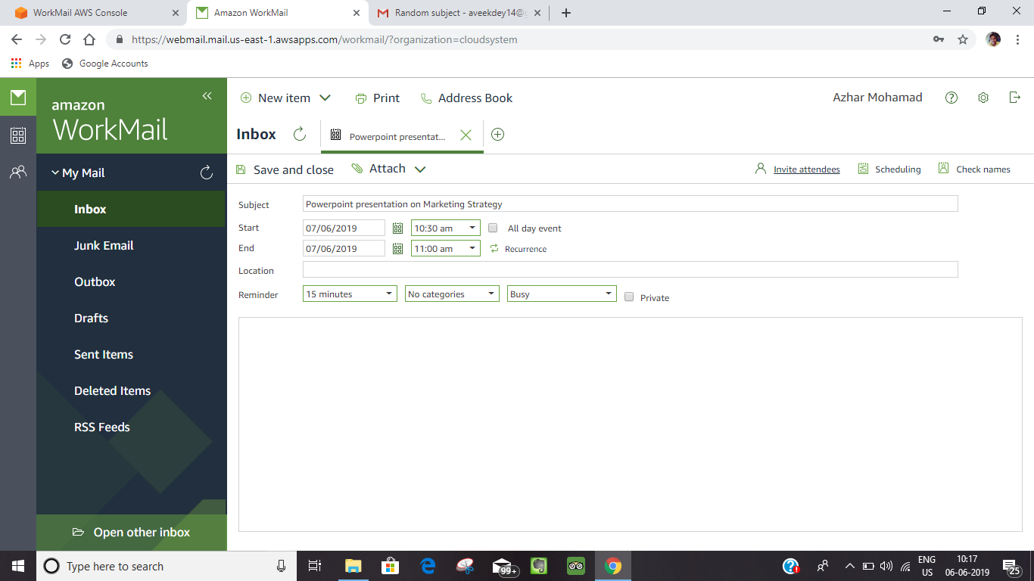

**4.Then this page will display.**

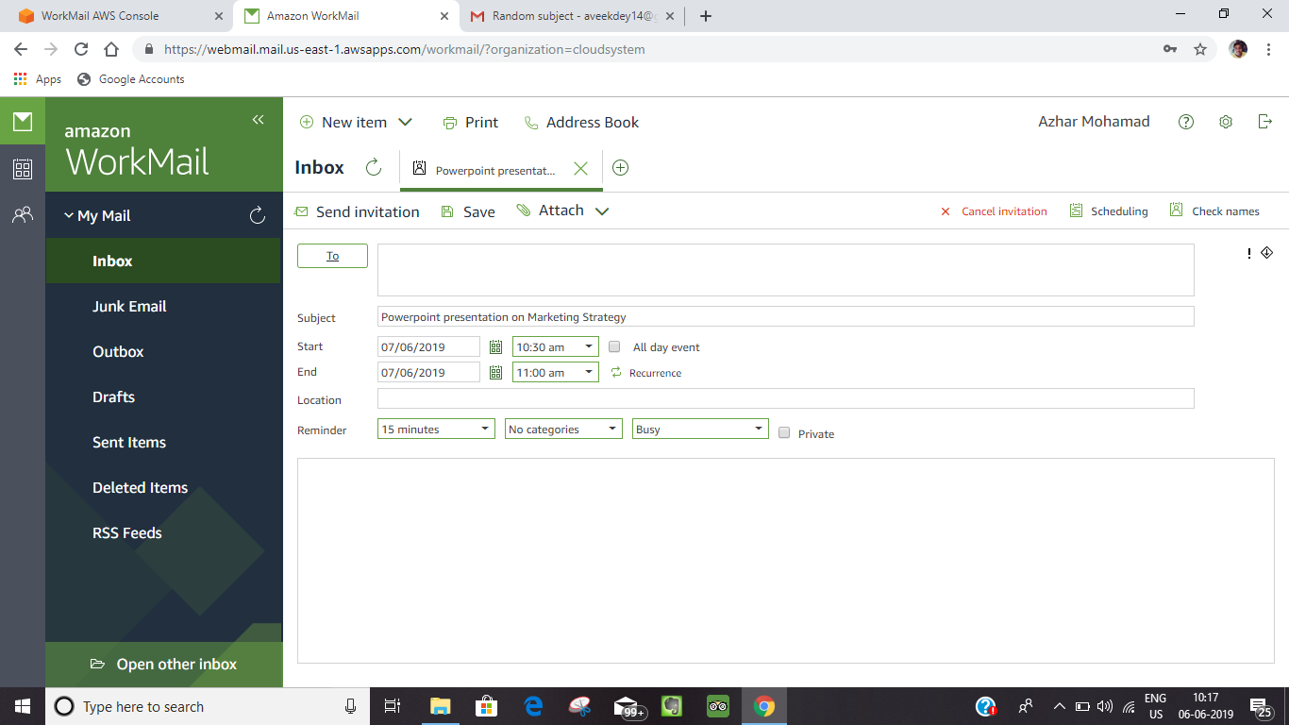

**5.Then click on TO button and add all the required details and in the resource add the resource which you are requesting for and click on OK button.**

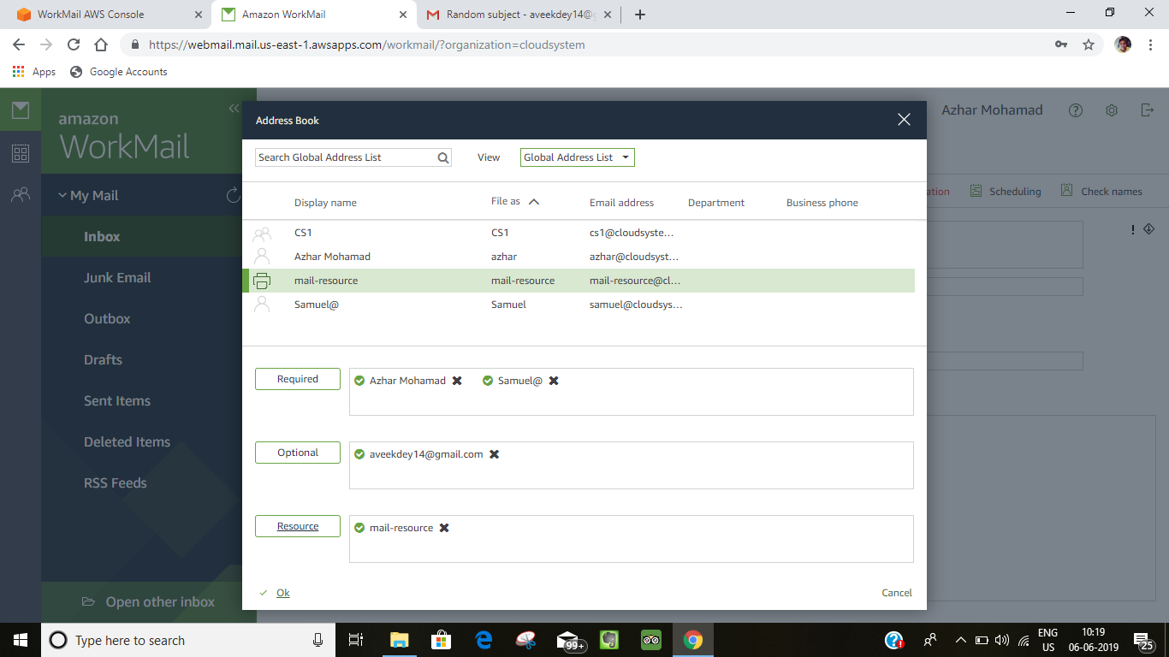

**6.Then fill-up the subject and the message-body and click on send invitation.**

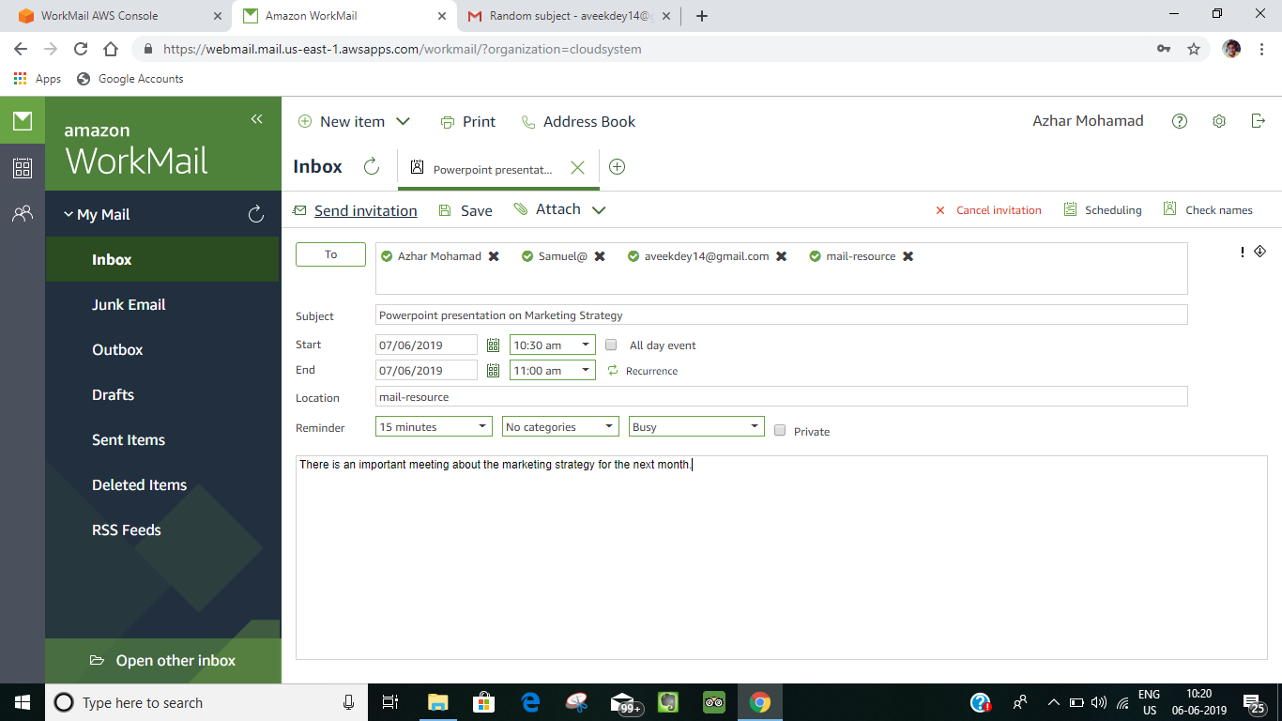

**7.Then the email will be send to the invitees(Required) like this.**

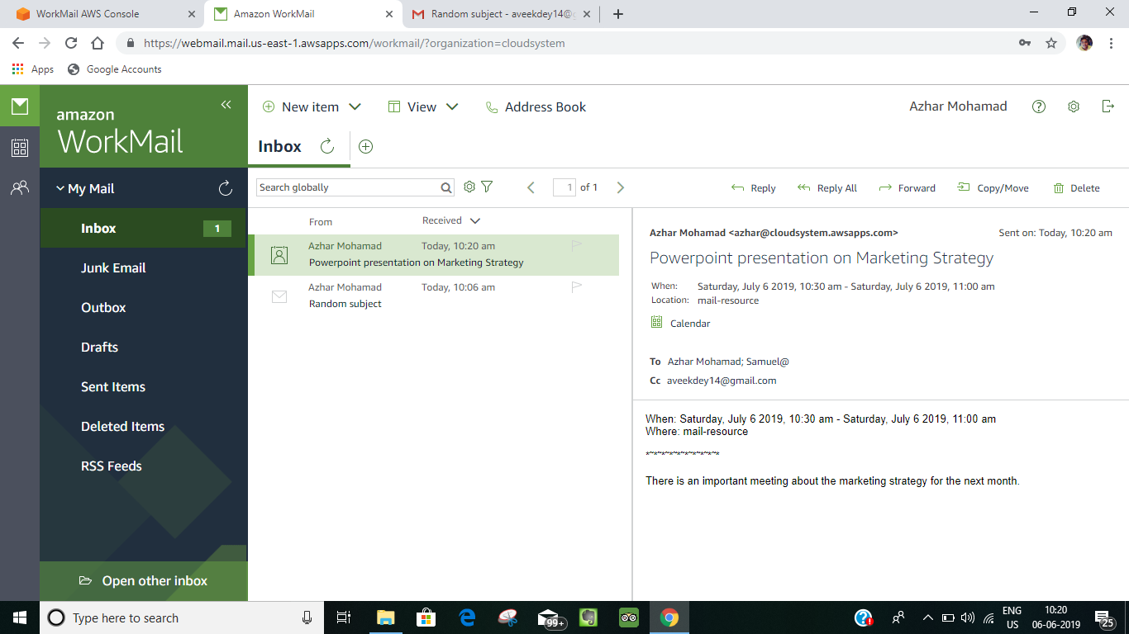

**8.And for the special guest (or optional) it will be received like this where he or she can choose whether he or she can come or not.**

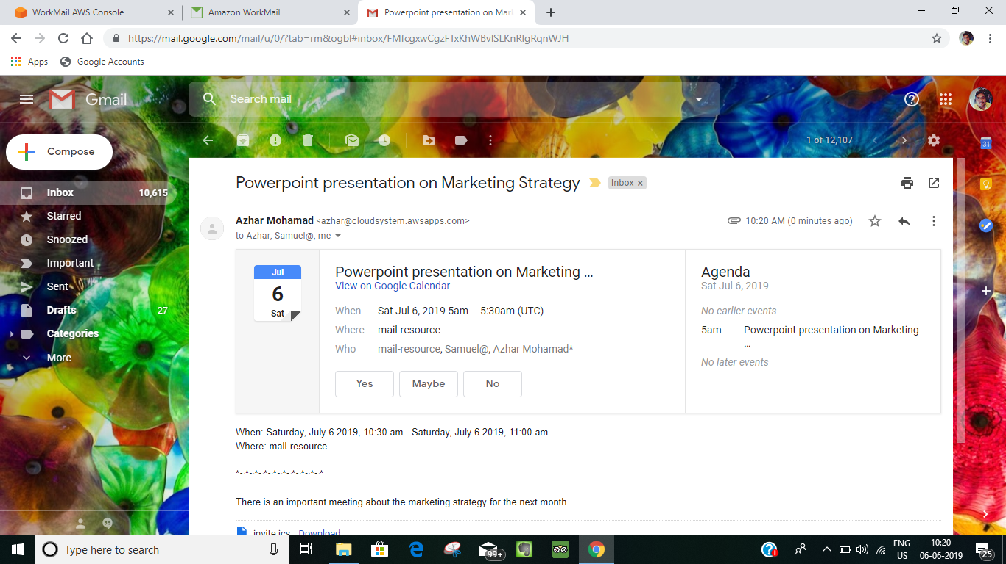

**If the optional user clicks any button from what is sent to the mail it will be sent as an email to all the invitees.**

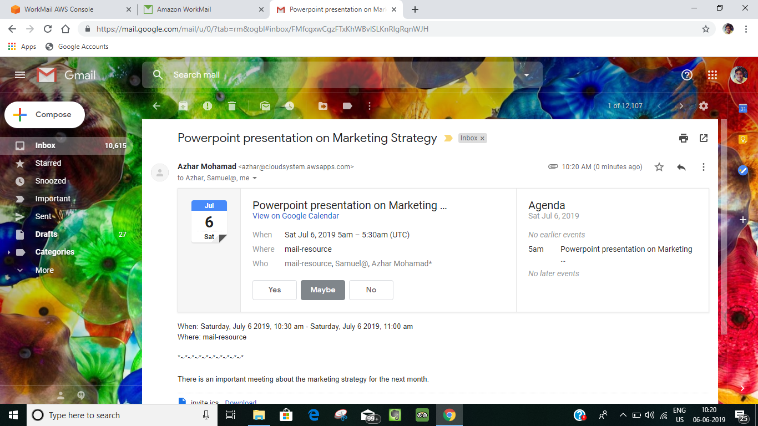

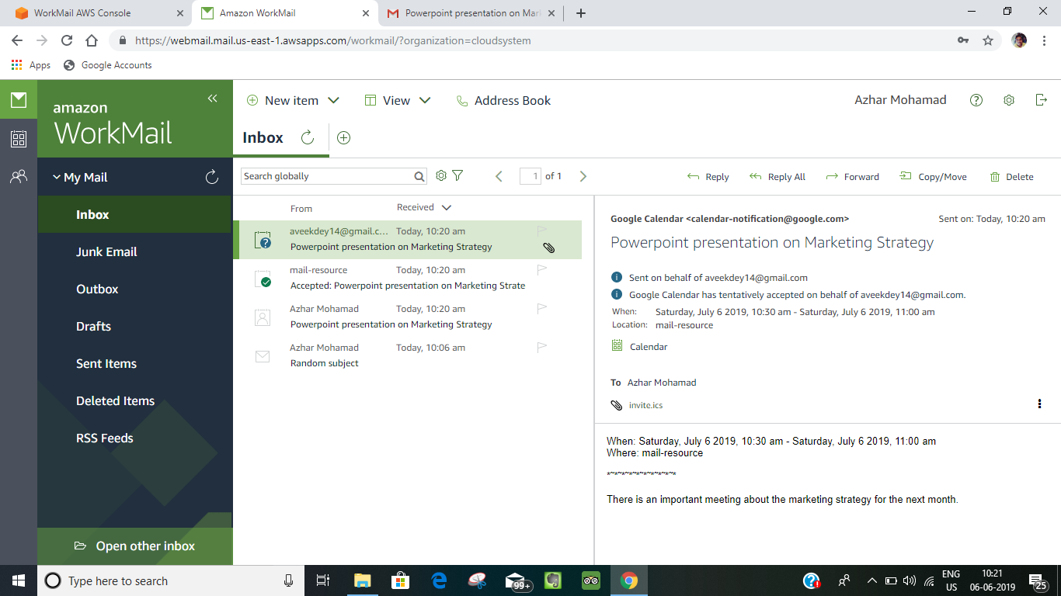

**In the “Resources” automatically all the request will be accepted because it is set to accept all the request which you can see from the “booking option”**

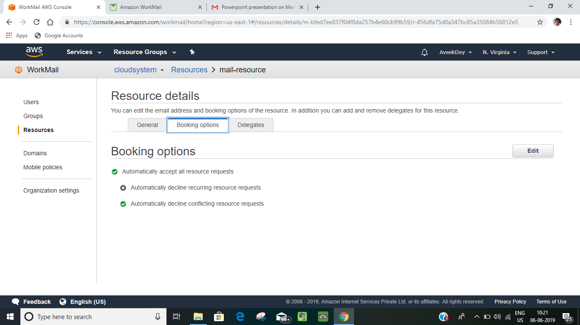

**So,as to change the settings from automatic to the availability or priority of the request we can follow the given procedure:**

**1.Click on the edit button from the “Delegates” from the “Resource” and the page will display like this .**

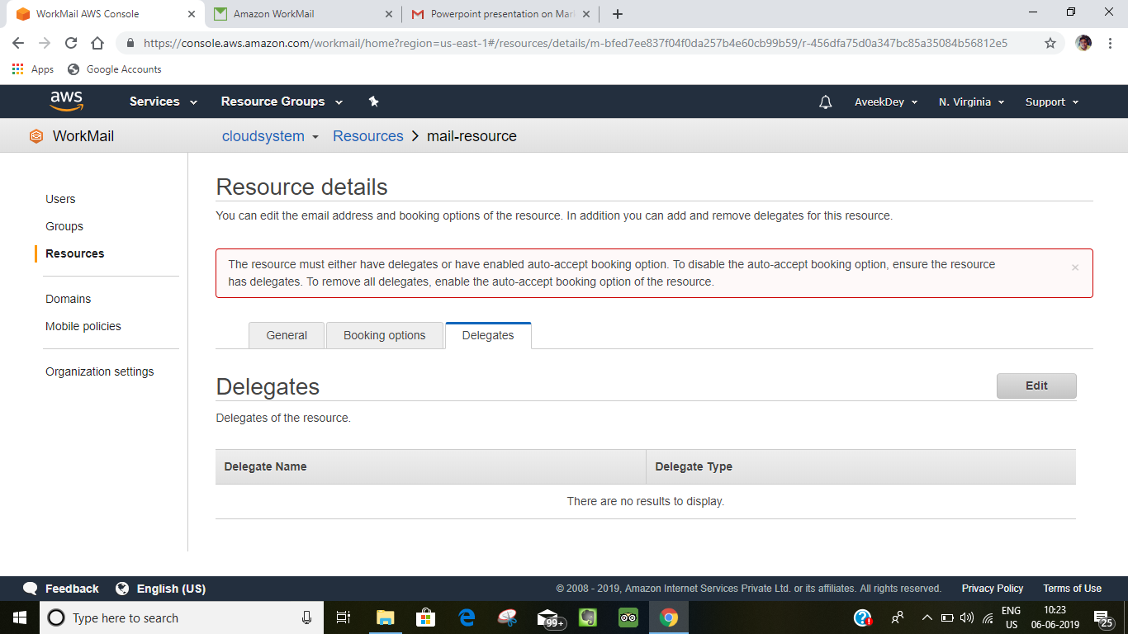

**2.Then it will say to add the delegate user or group ,then add the user or group whom you want to give the decision making option and then click on “save “ button.**

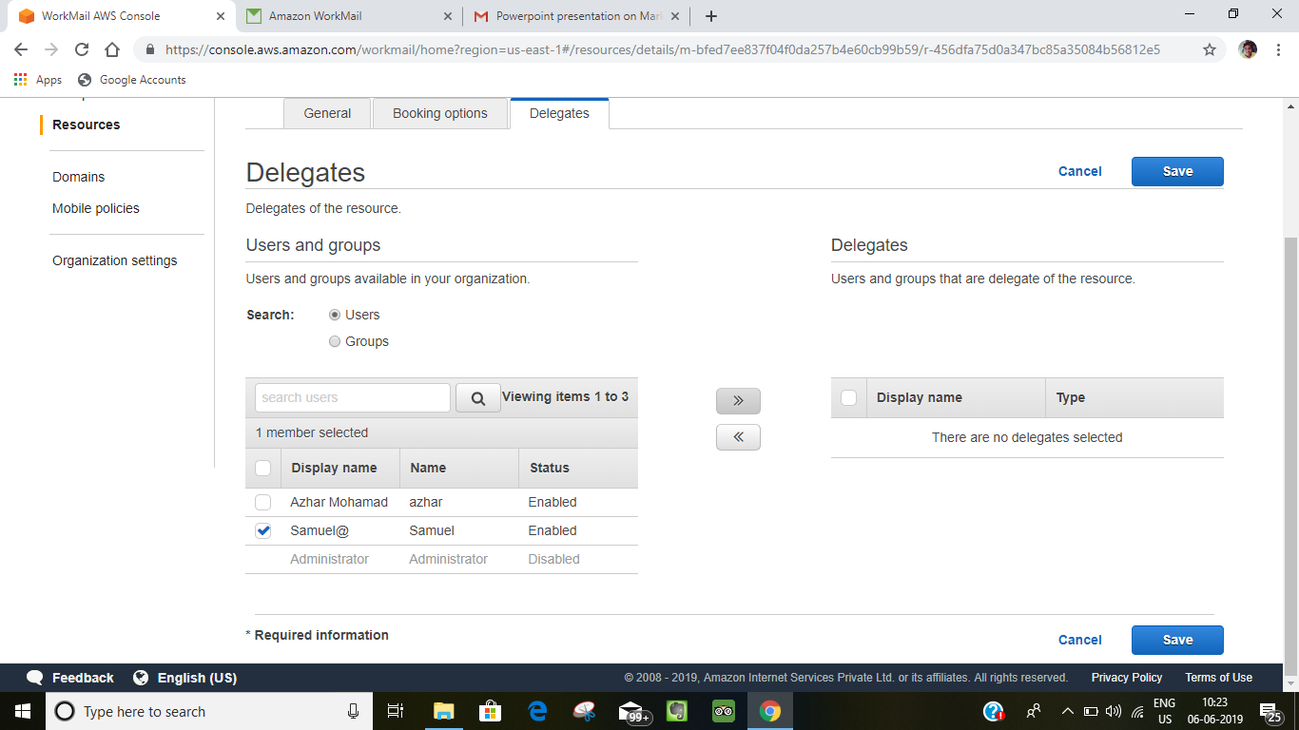

**3.Then it show the message as “resource updated” then after that and the “Delegate” will be added.**

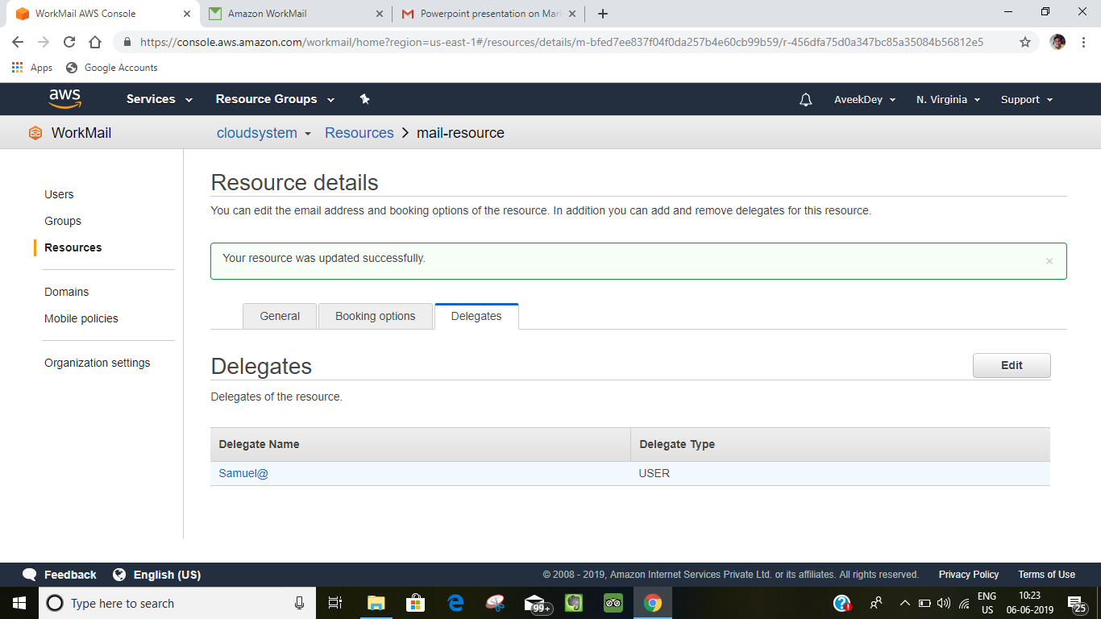

**4.Then go to “Booking option” from the “Resource” section and then click on the edit “option”.**

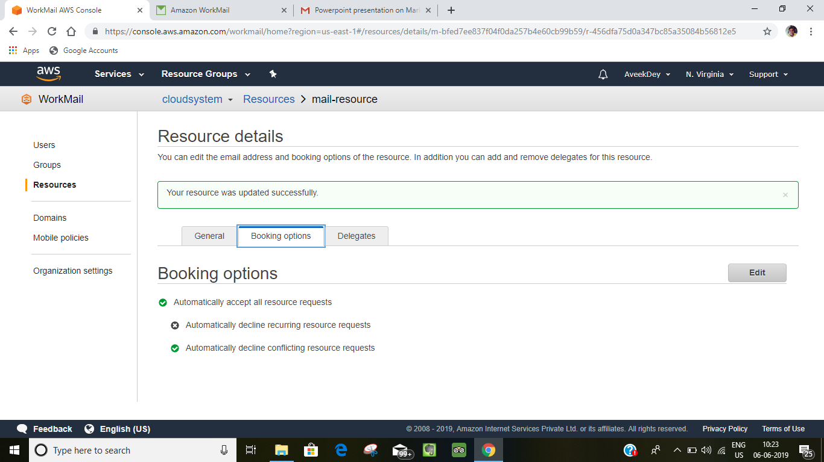

**5.Then untick on the “Automatically accept all the resources” and then save it.**

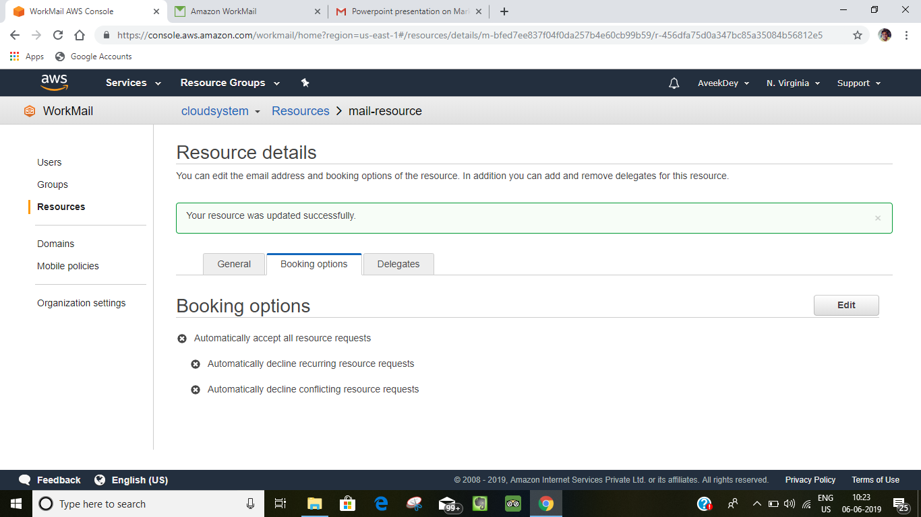

**Using Email Journaling with Amazon WorkMail**

You can set up journaling to record your email communication, using integrated third-party archiving and eDiscovery tools. This ensures that email storage compliance regulations for privacy protection, data storage, and information protection are met.

**Using Journaling**

Amazon WorkMail journals all emails that are sent to any user in the specified organization, as well as all emails sent by users in that organization. A copy of all emails is sent to an address specified by the system administrator, in a format called journal record. This format is compatible with Microsoft email programs. There is no additional charge for email journaling.

Two email addresses are used for email journaling—a journaling email address and a report email address. The journaling email address is the address of a dedicated mailbox or third-party device that is integrated with your account, where journal reports are sent. The report email address is the address of your system administrator, where notifications of failed journal reports are sent.

**Procedure:**

**1.Go to “Journaling” in the “Organisational settings” and then click on the “edit”.**

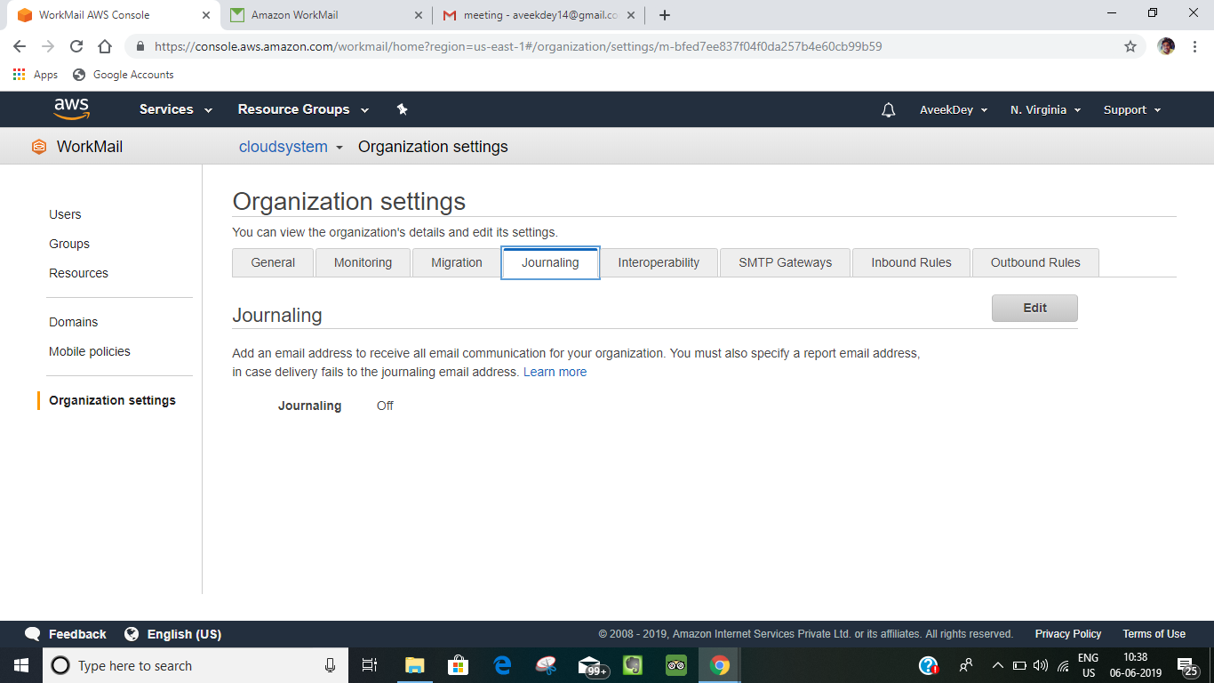

**2.Then click on the “on “ option and then fill up the “journaling email option” and “report email address”.**

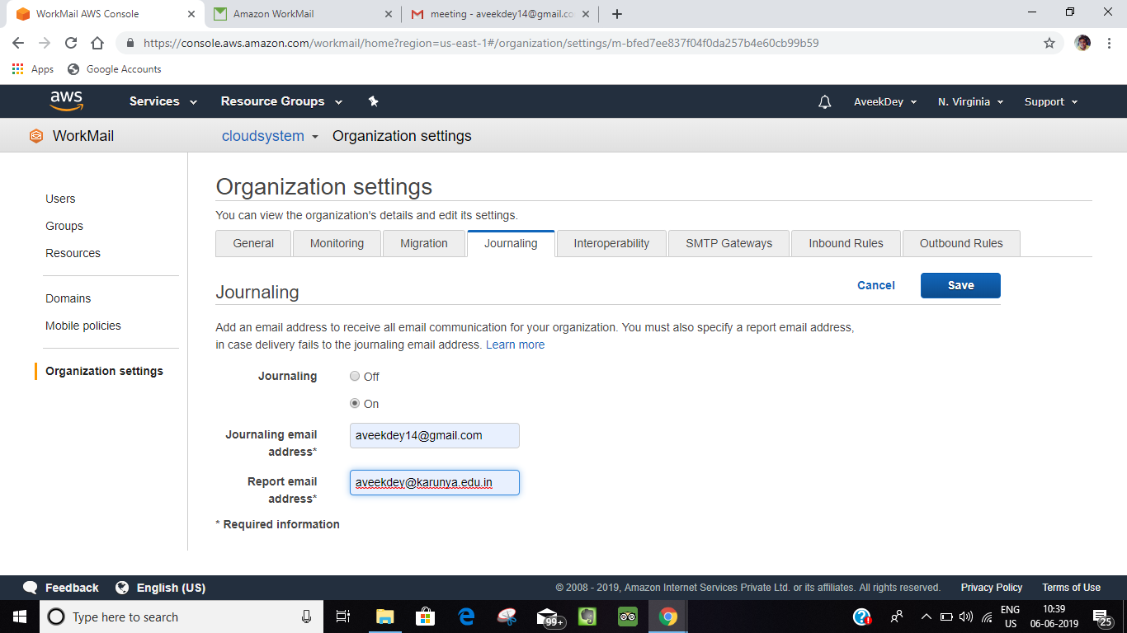

**3.Then if someone send email between themselves or to anyone then the report will go to the mail addresses.**

